|  |  |
| --- | --- |
| Horniman logo_black_left.jpg |  |
|  |  |

**Instructions on how to enter and leave the Gardens with a vehicle**

There are limited spaces on the Horniman site for blue badge holders and mini-buses.

To access these, please approach through Horniman Drive entrance. The postcode is **SE23 3BT** if you are using SavNav:

**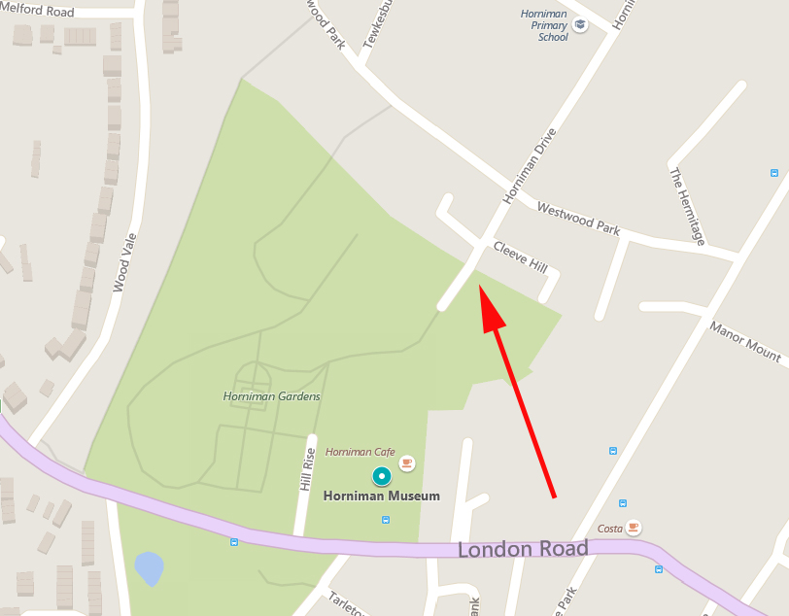**

Horniman Drive entrance

Ring the Intercom on the right by the gate and state you wish to park. If you cannot reach the intercom, please call Security Reception directly on 020 8699 1872.

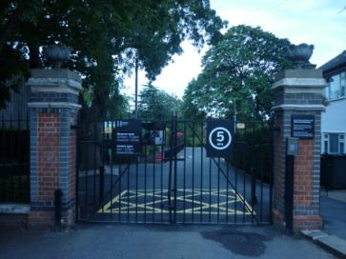

The driver will then need to drive at no more than 5mph through the Gardens with the vehicle hazard lights on.

If you have a workshop in the Pavilion, you should drop off on the flat land just as the path forks. Please do not park on the gravel.

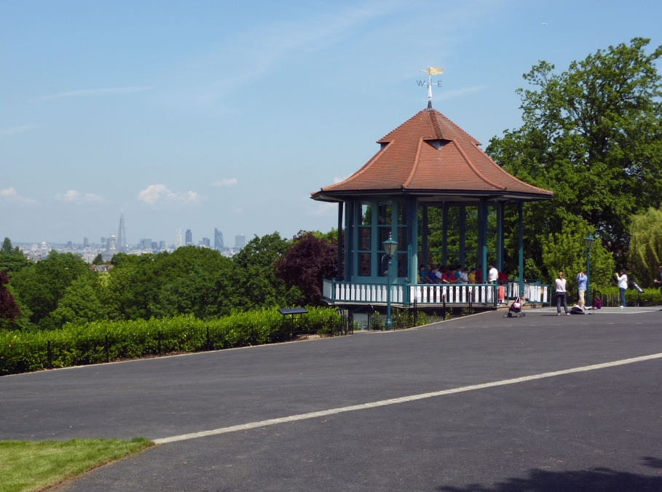

Minibuses and long vehicles should use the parking space which is situated near the bottom of the drive next to the grass roofed building

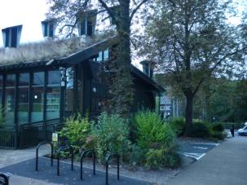

Cars should park in the spaces which can be found by taking the first left after the small toilet block.

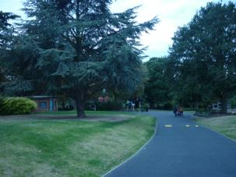

**Watch this short film showing the route from Horniman Drive to the Blue Badge parking:**

[**https://youtu.be/mHxF1qXAGko**](https://youtu.be/mHxF1qXAGko)