APPLICATION TO PHOTOGRAPH MUSEUM OBJECTS | 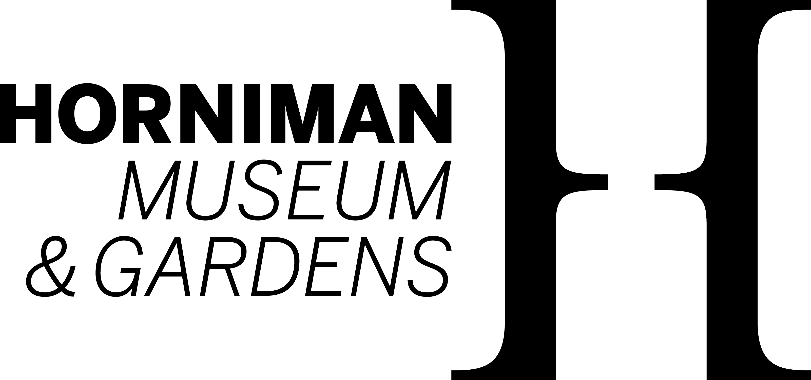
APPLICATION TO PHOTOGRAPH MUSEUM OBJECTS | Horniman Museum | Telephone | Email
APPLICATION TO PHOTOGRAPH MUSEUM OBJECTS | 100 London Road | +44 (0)20 8699 1872 | web@horniman.ac.uk
APPLICATION TO PHOTOGRAPH MUSEUM OBJECTS | Forest Hill
APPLICATION TO PHOTOGRAPH MUSEUM OBJECTS | London SE23 3PQ |  | www.horniman.ac.uk

Client details
Client: |  |  | Date sent to Finance:
Address: |  |  | Permission granted by:
 |  |  | Date:
 |  |  | Fee:
 |  |  | Invoice no:
Contact |  |  | Transaction no:
Telephone: |  |  | For Museum use only

PERMISSION IS REQUESTED TO PHOTOGRAPH THE FOLLOWING OBJECTS:
Object | Object number | Purpose of Image | Photography Brief/Other Comments | Col/  B&W

DECLARATION:
I hereby assign copyright in the above photographs to the Horniman Public Museum and Public Park Trust and undertake that the above photographs will be used only for private study or research. Should publication be considered I undertake to make a separate application on the appropriate Application for Reproduction Rights form.

Name (Block Capitals): Signature:

Position in Company: Date:

Horniman Public Museum and Public Park Trust
Core-funded by the Department for Culture Media and Sport
Company registration no. 245693. Registered office as above
Registered charity no. 80725

