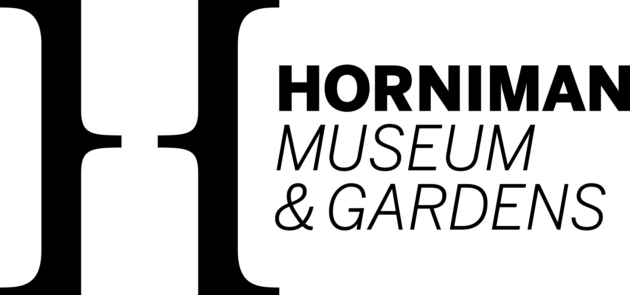

# **Access**

**Welcome to the Horniman! We have lots of information to help you plan your visit and know what to expect in advance.**

The Horniman would like to make visiting as accessible as possible for all of our visitors.

Find lots of information below to help you plan your visit and answer any questions you may have. We have also created a series of films which show you how the Horniman is on a typical day, in terms of visitors, lighting and noise levels. [Watch them on our YouTube channel](https://www.youtube.com/playlist?list=PLVLBYq1ay8T61ySxW8RZGoW56W718GDUW).

If you have any queries or require any assistance ahead of your visit, please phone 020 8699 1872 or email [enquiry@horniman.ac.uk](mailto:enquiry@horniman.ac.uk) - we'll be happy to help.

[Come visit us video](https://www.youtube.com/watch?v=eL5NEtrl2T8)

## Before Arriving

Please see the [Plan your Visit page](http://www.horniman.ac.uk/plan-your-visit/) to see a map of the area and details of public transport routes to the Horniman.

## Car Parking and Arrival

There are limited spaces for car and mini-bus parking available on the Museum site for Blue Badge Holders.

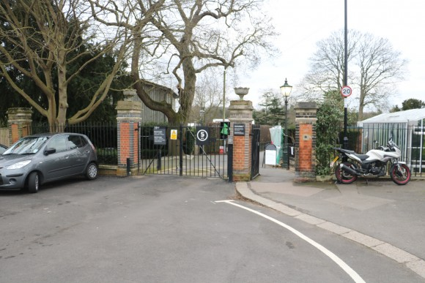

To enter the site you need to go to the Horniman Drive entrance - please use postcode **SE23 3BT**when using a SatNav or GPS.

The sign reads: Contractors, Deliveries and Visitors with Disabilities
Please use the intercom to report to our Security Team before entering.
If you experience any problems please contact the Horniman on 020 8699 1872.

There is a buzzer on the right-hand side, please press it to ask Security to enter.

If the buzzer is too high, please call 020 8699 1872 or email [enquiries@horniman.ac.uk](mailto:enquiries@horniman.ac.uk) in advance.

Watch this film which shows [how to get from the Horniman Drive entrance to the Blue Badge parking](https://www.youtube.com/watch?v=mHxF1qXAGko).

Please be aware that the path from the parking bays provided to the main entrance of the Museum is on a downward slope. Watch this film to see the [route from the Blue Badge Parking to the Museum entrance](https://www.youtube.com/watch?v=p5UXY0RRjTg).

Here is a downloadable pictorial guide about how to enter the site in a vehicle and where to park. If you are using a transport provider, we recommend printing this off and giving it to the driver.

[Instructions for Entering and Leaving the Gardens in a Vehicle - PDF](http://www.horniman.ac.uk/media/_file/instructionsenteringleavinggardensvehicle.pdf)   
(25kb – opens online)

[Instructions for Entering and Leaving the Gardens in a Vehicle - Word Document](http://www.horniman.ac.uk/media/_file/instructionsenteringleavinggardensvehicle.docx)   
(111kb – opens online)

## Main Entrance

The Horniman is fully accessible from the main public entrance on London Road.

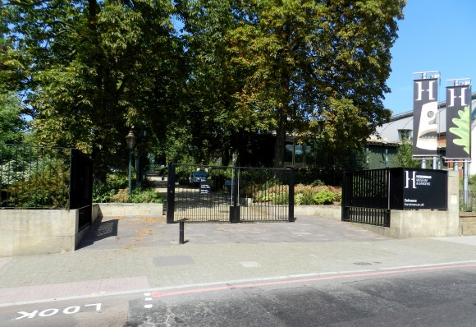

The path from the main gate to the Horniman entrance is approximately 150 meters long and is uphill. There are benches along the route.

The main entrance is to the right.

There are two sets of automatic glass doors at the entrance.

Please do not use the Clocktower entrance. This is for staff and deliveries only, and is not accessible for wheelchair users.

You can [walk the route from the London road entrance](https://www.youtube.com/watch?v=x70zz8clwUQ) in this short film.

## Main entrance Reception and Ticket Desk

Inside the main entrance there is a staffed Ticket Desk. Staff here are happy to offer assistance.

You can also speak to our Visitor Hosts who wear yellow lanyards.

Wheelchairs can be borrowed, free of charge, from our Ticket Desk.

All our wheelchairs will be sanitised following use.

Buggy parking is available in Gallery Square. Please note that all items are left at their owner’s risk.

## Tickets

Entrance to the Horniman Museum and Gardens is free.

There is a charge for visiting our [current family-friendly exhibition](https://www.horniman.ac.uk/plan-your-visit/ticket-information/), as well as the [Aquarium](https://cms.thehorniman.net/event/aquarium/) and [Butterfly House](https://cms.thehorniman.net/event/butterfly-house/).

Carers accompanying disabled visitors visit for free, but must book a ticket. See the [ticket information](http://www.horniman.ac.uk/plan-your-visit/ticket-information/) page for more details.

## Facilities

The Museum and Gardens are wheelchair friendly with accessible toilets in Gallery Square.

The Gallery Square toilets are open. Please follow social distancing advice when using the toilets. They will be cleaned regularly throughout the day.

The Museum does not provide hoists or adult changing rooms.

Café visitors are able to use the toilets to the right of the order counter. These toilets are not accessible from the Museum.

The cloakroom and lockers facility will not be available, so please only bring coats and bags that you can carry comfortably through your visit.

Buggy parking is available in Gallery Square and by the Butterfly House. Please note that all items are left at their owner’s risk.

A lift gives access to all the exhibition areas, including down to the Gallery Square toilets.

See the [plan your visit](http://www.horniman.ac.uk/plan-your-visit/) page for more information about the facilities at the Museum including the Shop and Café, lift access and wheelchair hire.

## Lighting levels

Some galleries have low lighting. Torches and magnifying glasses are available from the Ticket Desk to assist with reading. Gallery staff are also happy to help.

## Horniman Gardens

The Gardens have concrete paths throughout. Some of the paths are very steep and on wet or frosty days may not be suitable for wheelchair users or anyone who is unstable on their feet.

The ground on the [Nature Trail](https://www.horniman.ac.uk/event/nature-trail/) is uneven and can be muddy in rainy weather, so is not suitable for wheelchair users or anyone unstable on their feet.

Find out more about the Gardens:

* [Grasslands Gardens](http://www.horniman.ac.uk/event/grasslands-garden/)
* [Sunken and Display Gardens](http://www.horniman.ac.uk/event/sunken-and-display-gardens/)
* Rest of the Gardens

## Website Accessibility

This accessibility statement applies to [horniman.ac.uk](https://horniman.ac.uk) and [my.horniman.ac.uk](https://my.horniman.ac.uk/)

This website is run by Horniman Museum and Gardens. We want as many people as possible to be able to use this website and for it to be a useful tool for all. For example, that means you should be able to:

* change colours, contrast levels and fonts
* use a zoom to enlarge the text
* navigate most of the website using just a keyboard
* navigate most of the website using speech recognition software
* listen to most of the website using a screen reader (including the most recent versions of JAWS, NVDA and VoiceOver)

We’ve also made the website text as simple as possible to understand. [AbilityNet](https://mcmw.abilitynet.org.uk/) has advice on making your device easier to use if you have a disability.

### How accessible is our website

We know some parts of this website are not fully accessible, for example:

* some headings may not always appear in the most logical order if you are using assistive technologies to navigate the page.
* legacy PDF documents aren’t fully accessible to screen reader software, particularly older PDF resources.
* some components within our webpages do not work as well as they should at higher screen magnification settings.
* we use a third-party services to power our newsletter sign up form, donation forms and [my.horniman.ac.uk](https://my.horniman.ac.uk/) for buying Membership. Some elements of these service may not be accessible to those using keyboard navigation or assistive devices.

**If you need website information in a different format or would like assistance before your visit**

If you need information on this website in a different format like accessible PDF, large print, easy read, audio recording or braille:

* email – [enquiry@horniman.ac.uk](mailto:enquiry@horniman.ac.uk)
* call - 020 8699 1872

We’ll consider your request and get back to you as soon as possible.

If you cannot view the map or address on our [plan your visit page](https://www.horniman.ac.uk/plan-your-visit/), call or email us for directions.

If you have any queries or require any assistance ahead of your visit, please phone 020 8699 1872 or email [enquiry@horniman.ac.uk](mailto:enquiry@horniman.ac.uk) – we’ll be happy to help.

When you visit, you will find that our Ticket Desk has audio induction loops and can provide advice on how to best enjoy your visit.

### Reporting accessibility problems with horniman.ac.uk

We have untaken an access audit and are currently working with our auditors and developers to systematically correct and improve non-accessible parts of the site as soon as possible (see below for list).

If you find any problems not listed on this page or think we’re not meeting accessibility requirements, contact our Digital Team via [web@horniman.ac.uk](mailto:web@horniman.ac.uk).

### Enforcement procedure

The Equality and Human Rights Commission (EHRC) is responsible for enforcing the Public Sector Bodies (Websites and Mobile Applications) (No. 2) Accessibility Regulations 2018 (the ‘accessibility regulations’). If you’re not happy with how we respond to your complaint, [contact the Equality Advisory and Support Service (EASS)](https://www.equalityadvisoryservice.com/).

### Technical information about this website’s accessibility

Horniman Museum and Gardens are committed to making its website accessible, in accordance with the Public Sector Bodies (Websites and Mobile Applications) (No. 2) Accessibility Regulations 2018.

This website is partially compliant with the [Web Content Accessibility Guidelines version 2.1](https://www.w3.org/TR/WCAG21/) A and AA standards. Although we aim for full compliance, there are some areas where we do not meet this, and have listed these issues below.

We are currently working to fix these issues where indicated and will be updating this statement with the status of fixes and timescales as we work through them. We have also explained where we believe resolving issues would be a disproportionate burden to the Horniman.

### Non-compliant issues to be fixed

These are the details of content and features which are non-accessible, as well as which parts of the WCA Guidelines they relate to. We are working to correct these issues and are updating this area at the moment (July 2022).

* Occasional headings and sub-headings may not appear logically when using assistive technologies to navigate the page. (WCAG Level A 2.1: 2.4.1 and WCAG Level AA 2.1: 2.4.6)
* Some of the HTML code behind the site contains errors which may make it hard to navigate and read with assistive technologies. There are some parts of the site where the ARIA framework has been incorrectly implemented with no identified landmarks, which impacts how the site is read on screen readers. (WCAG Level A 2.1: 4.1.1, 4.1.2 and 1.3.1)
* The language of the page is not defined on some of the JSON downloads from the collections and some PDFs. (WCAG Level A 2.1: 1.3.1)
* Some buttons and frames, like videos and maps, are not properly titled within the page code and are not possible to bypass. (WCAG Level A 2.1: 1.1.1 and 2.4.1)
* When zooming in to 200% and above some menu items are lost, and page elements overlap. (WCAG Level AA 2.1: 1.4.4)
* Some images have too much alternative text, while decorative images should have no alternative text as they are not informative. Images which are used as jump links in the Learning Resource Section should include their purpose, not just the alternative text. (WCAG Level A 2.1: 1.1.1)
* Some icons are not pronounceable to a screen reader, and the scroll sideways arrow and magnifying search icons do not have an accessible name. (WCAG Level A 2.1: 4.1.2 and 1.1.1)

### Disproportionate burden

We’ve assessed the cost and resources needed to fix the issues below and believe that doing so now would be a [disproportionate burden](https://www.legislation.gov.uk/uksi/2018/952/regulation/7/made) within the meaning of the accessibility regulations.

* **Donate form (Donorbox):** Our donation forms found on the Donate, Project Coral and other fundraising pages are created using a third-party supplier (Donorbox), and the creation of our own donation mechanisms outstrips our digital development budget considerably at this time. New compliant donation tools are being developed as part of our new CRM and ticketing platform, in development 2022-23.
* **E-newsletters (Wordfly):** Our e-newletter and schools e-newsletters are created using a third party integration called Wordfly, as part of the new CRM platform. We are in the process of developing integrations with the Horniman website for bespoke sign ups in 2022-23. The general enews sigh up has been deployed.
* **Older PDF press releases:** The Horniman has numerous legacy PDF press releases which are not accessible but recreate what is available elsewhere in HTML page format on the site. We do not have the resource to retroactively make these PDFs accessible and accessible duplicates of these stories are available in the News and Stories section of the website.
* **Collections online:** Our Collections records number in excess of 100,000 records online and more are added daily. These records often have duplicated titles, and images with the same alternative text as the image title. Due to the high volume of records to amend, we do not have the staff resource to manually change how these records are titled and how the alternative text is generated. We are however, looking at what may be automated to achieve greater accessibility by December 2022.

### Content that’s not within the scope of the accessibility regulations

Some of the content included on our websites does not fit within the scope of the accessibility regulations. This includes:

* **Collections like scanned manuscripts and ledgers:** We have made transcripts and alternative text available where possible on manuscripts, ledgers and archival material, but this is not available on all of our text based digital collections.
* **Pre-recorded media published before 23 September 2020:** We will not be provided text transcripts or audio descriptions to non-essential video and audio created before this date, but all new content will include text transcripts or audio descriptions to help those with visual impairments understand what is happening in some of our videos and audio content. We will also be tackling essential video content created before this date, to be completed by January 2021.
* **PDFs and other documents published before 23 September 2018:** Some of our older non-essential PDFs documents and resources were published before 23 September 2018, and are therefore exempt from the accessibility regulations which [do not require us to fix PDFs or other documents published before 23 September 2018](http://www.legislation.gov.uk/uksi/2018/952/regulation/4/made). Any new PDFs or Word documents we publish will meet accessibility standards. We will also be tackling essential PDF content to be made accessible or converted to HTML pages completed by January 2021.
* **Live video:** Live video events which may be embedded on this site do not have captions. We do not have the resources to provide live captioning services during these events. Live video is [exempt from meeting the accessibility regulations](http://www.legislation.gov.uk/uksi/2018/952/regulation/4/made).
* **Third-party content:** We use a number of third-party content on our website. The design and implementation of these are not under our control, and therefore they are exempt from the accessibility regulations. However, we make them accessible where we can and raise any other issues with these suppliers. For maps in particular, we always make location information available in an accessible way via an address, so that the map is not the only way of obtaining information. These include:
  + Social networks (embedded tweets and posts, as well as sharing buttons and feeds from sites like Pinterest)
  + Google maps and CityMapper (interactive maps)
  + Video and audio hosting sites (YouTube, Vimeo, Acast, Soundcloud and Audioboo).

### What we’re doing to improve accessibility

We have an accessibility roadmap to show how and when works are planned to improve website and content accessibility, including the non-compliance issues above, which is available on request – [web@horniman.ac.uk](mailto:web@horniman.ac.uk).

### Preparation of this accessibility statement

This statement was prepared on 23 September 2020. It was last reviewed on 11 July 2022.

This website was last tested on 16 September 2020. The test was carried out by Zoonou.

We used this approach to deciding on a sample of pages to test:

* An example of each web page template type (ie, a blog, an event, an object record etc)
* Key areas of the site (homepage, contact us page, plan your visit etc)
* Pages that represented key user journey’s through the site (what’s on, access etc)
* Site functionality and forms (search box, events calendar, PDFs etc)

For more details about our website accessibility testing, please contact the Digital Team: [web@horniman.ac.uk](mailto:web@horniman.ac.uk)

## Our staff

Speak to one of our Visitor Hosts if you have a question – they wear the yellow lanyards.