# End-of-trial evaluation

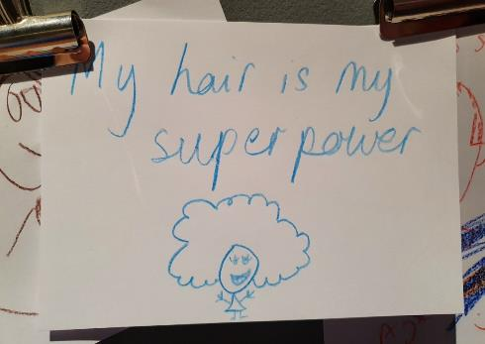

Contents

**Glossary** 3

**Executive summary** 4

**Evaluator’s note** 6

**1. Introduction** 7

**1.1 MAGNET** 7

**1.2 The project** 8

**1.3 Monitoring and evaluation methodology** 8

**2. What difference did the trial make?** 12

**2.1 Trialling the MAGNET approach** 12

**2.2 Developing exhibition concepts and a pilot** 16

**2.3 Hair: Untold Stories** 27

**3. Summary of lessons learnt and recommendations** 41

**4. List of Appendices** 45

This project has been delivered by the MAGNET Touring Exhibition Partnership with lead exhibition development and hosting by:

Hair: Untold Stories was curated in partnership with Goldsmiths University



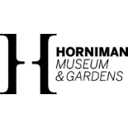

And funding from the:





This evaluation was commissioned by MAGNET and has been undertaken by Heritage Insider Ltd.

Photos: Copyright Heritage Insider unless otherwise stated.

Completed May 2022 (v4). Amended October 2023 for external circulation (v5).

# Glossary

**Co-developed exhibition** **–** an exhibition where the content has been developed by two or more organisations working together.

**Community collaborator –** a generic term to refer to community fieldworkers, members of the community and artists who have contributed to the exhibition.[1]

**Co-production –** a process of collaborative thinking or production with others, for example with members of a specific geographic or demographic community, or community of interest, where the power dynamic is shifted to be more evenly spread across contributors.

**Hosting** **–** receiving an exhibition from another organisation.

**MAGNET –** acronym for the Museums and Galleries Network for Exhibition Touring.

**Touring** **–** any exhibition that has been, or will be, hosted at multiple venues.

# Executive summary

The MAGNET network was established in 2020 and consists of 10 museums and galleries that aim to pool resources, develop curatorial expertise, share their collections with diverse national audiences, and encourage experimentation and risk in exhibitions – in subject matter and approach.

The network has been supported by the Art Fund to develop as a partnership and trial a first partnership-collections-based exhibition designed to tour nationally. MAGNET used this opportunity for a highly ambitious trial to test three ways of working: the MAGNET model of co-development across partner organisations, touring and a community co-production model.

Whilst MAGNET is still in its relative infancy, it has many tangible benefits to offer partners, the sector and audiences. The pilot has:

* Brought professionals together during the pandemic within organisations and across the partnership
* Built the resilience and capacity of the MAGNET partnership
* Developed three ‘funding-ready’ exhibition concepts for partner co-development
* Provided proof of concept for touring co-developed, co-curated collections-based exhibitions
* Helped support the host museum in recovery and in creating an ‘appointment to visit’ for existing and new audiences
* Begun to de-risk the prospect of developing touring exhibitions, for example by providing vital ‘match-making’ of partners and tour hosts.

If the identified sector barriers to touring excellent content and widening participation are to be surmounted, then networks such as MAGNET are vital. MAGNET provides space for collaboration, the exchange of skills and knowledge, debate and exploring risk in object-based interpretation.

The trial exhibition Hair: Untold Stories is a best practice example of community co-production. The exhibition team created a welcoming and inclusive space in which a wide range of contributors could feel comfortable and confident to create content.

The finished exhibition brings together high-quality interdisciplinary content that has already been seen by over 100,000 visitors[2]. The result is a dialogue between historical and contemporary objects, artworks and community voices from past and present. This gives a richness to the experience for visitors. Together, the subject matter, perspectives, content and presentation have proved highly relevant to a wide range of people, making a personal connection with audiences that many exhibitions strive for but rarely attain in such a far-reaching and meaningful way.

If we are to democratise museum collections, then the sector needs exhibitions such as Hair: Untold Stories. And furthermore, it needs supportive environments in which museum professionals, communities, stakeholders and artists can collaborate to form new narratives. In this way, museums will find relevance for audiences that they have struggled to reach in the past and will form long-term relationships with them to deepen understanding and bring museums to the heart of the community as a place for reflection, debate, place-making, expression and inspiration.

A suite of practical recommendations has been informed by the findings of the evaluation process. These are:

**EV1 Make space and dedicate resource to further develop the MAGNET network to help support museums** – To function effectively, further investment and consolidation is needed before any large-scale scaling-up. This will ensure that a framework for developing, managing and hosting touring exhibitions is in place:

* Ensure the governance structures are fit for purpose
* Create a final Touring Exhibitions Strategy
* Build a toolkit for developing and managing MAGNET touring exhibitions
* Undertake a Skills Needs Analysis to inform a CPD programme
* Ensure policies and protocols are in place.

In addition to the above, if partnership working is central to MAGNET’s unique offering, time should be set aside to develop this aspect of the network and external expertise brought in if required.

**EV2 Define the model for each exhibition** – During development there are six key questions to help define the approach for individual future exhibitions. Answering these will help agree the most appropriate model:

**Q.** What model of touring exhibition development is appropriate? For example co-developed or developed by an individual organisation and offered for tour

**Q.** Which economic model do we want to use?

**Q.** What level of community engagement and/or co-production should we be aiming for?

**Q.** How will other contributors, such as artists and creative practitioners, be involved?

**Q.** Will local tailoring of exhibition content and programming add value for host museums? And what percentage of the package could be made bespoke for the host museum? And then consider:

**Q.** Have we costed, and then resourced, the exhibition appropriately to deliver our desired model?

These questions should be discussed during exhibition development. Consideration of how community stakeholders should be involved in these discussions should be made.

MAGNET should build upon the momentum created by the trial exhibition by:

1. Securing funding to move the new exhibition concepts from co-development to delivery
2. Sharing the learning from the trial more widely and applying for awards for Hair: Untold Stories.

**EV3 Refining the exhibition development process** – Lessons learnt from the trial exhibition development process should be fed into future exhibitions.

**EV4 Evidencing impact** – Integrate evaluation into future project proposals and exhibition plans, including the development of standard evaluation tools. Appoint the evaluator early in the project delivery or even during development to allow them to observe and collect data along the whole journey of the project. Capacity can be extended by recruiting volunteers to collect additional data and be involved in analysis if they would like to.

A formal evaluation of the network’s activities should be undertaken on a triennial basis and evaluation should be integrated into the resourcing for each exhibition.

# Evaluator’s note

Heritage Insider has evaluated over 150 projects and programmes and our research team has found Hair: Untold Stories a stimulating and inspiring exhibition to evaluate. It has provided a concrete example of how museum spaces can evolve to be more democratised by including a wider range of voices, and by partnering with others to bring these voices into the narrative.

In turn, the new stories produced as a result have provided additional interest for audiences – adding to the visitor experience for both existing and new gallery-goers.

The majority of the projects and programme we are asked to evaluate aim to widen participation, for example, by bringing new visitors through the door or reshaping events programmes to have a broader appeal and to be more accessible. A few of these projects and programmes also aim to collaborate and co-produce with audiences. Fewer still evaluate the process and results well. Despite setting out with these aspirations, few find it possible to fully deliver on them. Hair: Untold Stories has bucked the trend by testing new ways of working that can truly enhance future programming.

It was a privilege to stand and watch visitors’ journey of self-discovery and sense-making as they travelled through the gallery. We found this journey to be well-evidenced in the Personal Meaning Maps, as people explored with us how their thinking, perceptions and awareness had changed as a result of visiting the exhibition.

On top of self-reflection, the well-executed content prompted discussion between friends and peers, hair professionals, officiandos and influencers, parents/carers and children and educators and pupils, couples and young people. Observation helped us to spot this behaviour, and to understand it better through talking to visitors, asking ‘vox pop’ questions and seeing their own personal additions to the exhibition (in the form of comment cards and drawings).

The exhibition was not just a presentation of objects and facts, or even personal stories. Instead it created a deeper, richer space to develop thinking, strengthen personal identity and gain perspective (especially about our own ‘bad hair days’!).

Hair: Untold Stories showed the raw power of this approach. The future could be bigger, better, more. Bigger spaces dedicated to this kind of approach, better resourcing, more expansive programming and deeper collaborations with audiences once the exhibition is opened (in addition to during development).

This exhibition development process has been a pathfinder for new, reinvigorated interpretative practice that can help to find relevance in contemporary society, and to place our museums, arts and cultural organisations at the heart of communities.

Finally, working alongside volunteer evaluators was a joy. There is no formal career path into evaluation[3], yet our sector needs these skills to help understand the impact of its work, identify opportunities and potential, crystallise lessons learnt, leverage and effectively allocate resources and, ultimately, enrich practice. Volunteer and traineeship roles provide a great way to get a taster of measuring impact. We need more organisations to develop, recruit to and support roles like this – hats off to MAGNET for getting stuck in.

# 1. Introduction

## **1.1 MAGNET**

**Context**

The 2017 Mendoza report discussed ways museums could develop ‘a new partnership framework to extend their reach throughout England in a more strategic way’.

In recent years, regional museums have faced significant challenges to achieving this, for example they report a lack of affordable touring exhibitions of sufficient quality to meet their audience development objectives, meet public expectations and generate revenue. Budget cuts have reduced their ability to generate their own exhibitions, such that those museums accustomed to four exhibitions per year that are now reduced to delivering two, of lower quality.

This has created a risk-averse situation, stifling innovation and hindering the ability to serve new and existing audiences, to make the most of the engagement opportunities presented by their collections and to generate sustainable revenue.

**Establishing a partnership**

MAGNET (the Museums and Galleries Network for Exhibition Touring) was established in 2020 with the support of the Art Fund. It is a network of 10 museums and galleries[4] that aim to pool resources, develop curatorial expertise and share their collections with diverse national audiences.

Current active MAGNET partners are:

* Horniman Museum and Gardens (current lead)
* Bristol Museums
* Derby Museums
* Glasgow Museums
* Manchester Museum
* National Museums Liverpool
* Royal Albert Memorial Museum, Exeter
* Museums Sheffield
* Tullie House Museum and Art Gallery, Carlisle
* Tyne & Wear Archives & Museums.

The majority of the partners are based outside London, allowing for a rebalancing investment agenda across the UK.

Together the partners aim to:

1. Test new funding and delivery models for quality touring exhibitions sector-wide, embedding collaboration as a cost-effective and sustainable way of working
2. Encourage experimentation and risk in exhibitions, in subject matter and approach (co-curation, co-production, etc.)
3. Allow museums to pursue their ambitions for audience engagement and diversity in meaningful ways through exhibitions, making a wider breadth of cultural experiences available to more people
4. Build skills across the sector, e.g. remote collaboration, sustainable exhibition-making practice, collaborative work on learning, commercial and digital. It will provide partners with a forum for the learning process, uniquely working as a peer group to evaluate MAGNET’s projects collectively
5. Raise the profile of regional collections amongst UK-wide audiences, placing them in the context of a great national public collection
6. Offer potential for product development and shared commissioning of new commercial opportunities and products
7. Offer potential for shared development of learning and outreach programmes.

## **1.2 The project**

In 2019, the MAGNET partner developed the concept for a long-term, five-year, funded partnership. It had a positive reaction and encouragement from funders including Arts Council England and the Art Fund.

However, following the Covid-19 outbreak, the funding landscape rapidly morphed as funders redirected their resources into emergency funding and activities focussed upon supporting individual, community and societal Covid-19 recovery.

Wanting to maintain momentum but mindful of the shifting context, the MAGNET network rethought the full-scale pilot into a smaller project that was more achievable within the pandemic operating environment. The partners hoped that the model of working would be a powerful tool in helping the limited funds that museums have for exhibitions go further and would support collaboration in a post-coronavirus world.

The scaled-down project was supported by the Art Fund to:

* Development as a partnership
* Trial a co-curating, collections-based exhibition with high-quality interdisciplinary content designed to tour nationally.

This document comprises an evaluation of this pilot project.

## **1.3 Monitoring and evaluation methodology**

Specialist independent evaluator Heritage Insider Ltd was appointed to undertake an end-of-pilot evaluation. The brief from MAGNET was to evaluate the success of both MAGNET and the pilot exhibition (Hair: Untold Stories) from December 2021 to June 2022, to inform future plans and feed into reporting to the funders and partners. The following areas were identified by MAGNET for evaluation:

|  |  |
| --- | --- |
| **MAGNET** | **HAIR: UNTOLD STORIES** |
| Skills development | Funding and collaboration |
| Profile of partnership | Exhibition development |
| Shared commissioning  New ways of working | Attracting new and diverse audiences |
| Shared learning, outreach and PR | Successful outcomes as set out in Exhibition Interpretation Plan |

The resource allocated for the evaluation planning, data collection, analysis and reporting was small compared with the data required to effectively investigate all nine topics listed above, evaluating both an organisation (MAGNET) and a product (the pilot exhibition). It was therefore agreed to take a pragmatic approach the to the evaluation, namely:

1. Prioritised use of evaluator time to evaluate the pilot exhibition as a case study of how the MAGNET approach can work and provide a light-touch review of MAGNET as an organisation. For example two reflective practice sessions were held – one with MAGNET and one with the exhibition development team – but individual MAGNET partners have not been interviewed as part of the process, due to a lack of allocated resource to cover the cost of this
2. The project focussed on the main pilot exhibition within the Studio Gallery space at the Horniman Museum and did not attempt to evaluate the other two elements of the Hair project – Cult Hair and Intimate Archives
3. Evaluator and client capacity to collect data were supplemented through recruitment of two new temporary volunteering opportunities. Volunteers were Mengjiao Zhao and Edoardo Lena[5]
4. Evaluation data was collected up until end April 2022 rather than June as originally planned, to better reflect the end-of-project timescales
5. The final report is a high-level summary, rather than a detailed evaluation of each topic.

A Monitoring and Evaluation Matrix[6] was created to plan the evaluation process.

**What does the evaluation process seek to find out?**

Key evaluation questions[7] (KEQs) help to frame the evaluation and to guide both the collection of data and how the data is interpreted to form findings and recommendations. The evaluators used the agreed questions below to assess the overall success of the Hair exhibition and feed into the evaluation of the MAGNET partnership:

* What has worked for MAGNET partners?
* What can we learn from developing Hair?
* Has Hair met its aims in attracting new and diverse audiences?
* What do new visitors think about Hair?
* Did we meet visitor expectations?
* Did anything surprise, challenge, frustrate visitors?
* Was the content pitched at right level for visitors?
* What was the main learning/takeaway from the exhibition for visitors?
* What can we do to improve the offer for visitors?
* How do visitors use the exhibition space? What draws their attention?

In answering these questions, a suite of practical recommendations has been created (see Section 4).

**How was the evaluation undertaken?**

A mosaic approach[8] was used for this evaluation, combining several evaluation techniques. This has allowed triangulation[9] of data to create a robust and rounded view of MAGNET’s journey and what difference it has made (outcomes and impact). Data-collection methods are listed below:

* 1. Review of original project plans and documents[10]
  2. Visitor number count[11]
  3. Arts Council Impact and Insight funder survey[12]
  4. Fresh Eye visit to the pilot exhibition[13]
  5. In-gallery visitor tracking[14]
  6. In-gallery visitor behaviour observation[15]
  7. Personal meaning mapping face-to-face with visitor samples[16]
  8. Vox pop interviews and mini surveys conducted face-to-face with a visitor sample[17]
  9. Independent key informant telephone interviews[18]
  10. Two reflective practice, project learning review sessions[19]

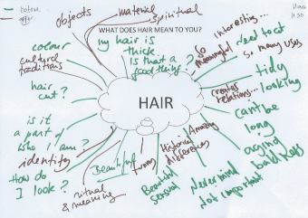

Figure 1 Example of a visitor tracking map and a personal meaning map showing people's feelings, thoughts and relationship with 'hair' before and after their visit to the exhibition.

**Limitations -** there are always factors which limit an evaluation process and evaluators work to minimise the impact of limitations and bias on the evaluation process and findings.

**Covid-19** **–** The pandemic has affected the visitor numbers and patterns of visitation at the Horniman Museum and Gardens. This will be the result of multiple factors and it is therefore difficult to quantify the impact of the pandemic upon Hair exhibition visitors.

**Resource –** The evaluator brief covered two interconnected, but quite different, elements: the strategic MAGNET partnership and the practical process of exhibition development and the output. The funder requires a ‘full financial analysis of the total Project costs and the application of the Grant’ - this is outside of scope for the external evaluator and should be provided by the MAGNET team. The evaluator has also had to be pragmatic about allocation of time, for example a full rapid thematic analysis of vox pops and mini surveys was not possible within the budget.

Planning for future evaluations should include a review of how practical the requested data collection and outputs are within the budget allocated for evaluation and narrowing down of the brief accordingly, see EV4.

**Timing of evaluation contract –** The external evaluator was appointed late in the project, just a few weeks before the pilot exhibition opened, and to report before the end of the first exhibition run. It was therefore necessary to construct a picture of the activity retrospectively, which is not ideal. In future projects it would be useful to appoint the evaluator early in the project delivery or even during development to allow them to observe and collect data along the whole journey of the project (see EV4). Full stats pertaining to the exhibition’s residency at the Horniman Museum and Gardens cannot be included within this report, nor any evidence from the exhibition’s run at the other two host museums.

# 2. What difference did the trial make?

## **2.1 Trialling the MAGNET approach**

**Deepening collaboration**

Prior to MAGNET, the partner Museums did liaise and work together but work on areas such as loans and exhibitions has been more transactional than true collaboration.

This resilience-building and exhibition piloting project has allowed MAGNET partners to maintain the impetus they have generated since inception and to deepen collaboration. The pilot project has enabled MAGNET to:

* Explore solutions for more sustainable ways of working on touring exhibitions
* Build capacity by developing working methods, trust and understanding across organisations and teams
* Develop a number of exhibition concepts (see Section 2.2) and deliver a pilot exhibition touring three venues (see Section 2.3)
* Help find relevance for target audiences, including those from previously underrepresented audiences, through finding relevance and new ways of co-production and collaboration with communities to interpret historic and contemporary issues
* Begin to develop practical tools to assist in developing future exhibitions and identify where further work on systems and processes would be beneficial (see Next Steps).

When viewed against the sector-wide backdrop of all museums looking to maximise resources and collaborate in order to survive and thrive, collaborations such as MAGNET seem ‘business critical’ for museums in the future. The MAGNET partnership has the potential to make the collections of the whole network accessible to the public in a meaningful way.

By pooling resources, the partners have been able to offer a high-quality, co-curated exhibition to attract diverse audiences, and shine a spotlight on amazing collections. In this way help museums can turn their resources (expertise, venues and collections) into a shared asset for the benefit of the sector and for audiences.

The MAGNET approach is designed to help museums surmount the most significant barriers to touring,[20] match-making between suitable partners. MAGNET has a ready-made pool of nationwide partners that are networked together and ‘exhibition-ready’ to develop their exhibition concepts into touring exhibitions. These partners can both co-develop and host exhibitions, providing a ready market for touring exhibitions produced. However, there could be wider benefit to the sector by also offering exhibitions outside of this core group or by expanding the group.

The model also helps to ‘de-risk’ touring for both hosts and those co-developing exhibitions by leveraging funding, providing support, sharing exposure to risk and sharing expertise.

**Maximising partner engagement**

Staff ‘churn’ during the pandemic has presented challenges to maintaining continuity in staff attending MAGNET meetings, and also in progressing strands of work without repeatedly having to cover old ground. MAGNET has been flexible in who attends meetings and is engaged in different areas of work to help overcome this.

Partner engagement in MAGNET and the pilot exhibition has been partly reliant on the level of curatorial interest. Involvement from other departments and teams, for example learning and engagement, has been less consistent. More input from learning specialists would usefully help to bring further expertise in some areas of audience engagement into the exhibition planning process, for example to help develop programming, interactives and elements such as family appeal.

Furthermore, clarity on who should be attending MAGNET and exhibition meetings from each partner would be useful.

**Capacity to run MAGNET**

The role of a coordinator is key to any network. Coordinators provide the capacity to bring partners together, manage funder relationships, document decisions and discussions, help ensure processes and protocols are in place and being used, communicate on a regular basis and help organise the exhibition development, delivery and evaluation processes.

MAGNET has had churn in its coordinator role and is now on its third person in this post. This has caused disruption and loss of efficiency. A good network coordinator is worth their weight in gold to help optimise the activities of the network and make it easy for partners to take part and gain benefit from a network. This role is essential and ideally the central team would be expanded to develop three paid roles:

* MAGNET Relationship Manager
* Exhibitions Development Coordinator
* Network Administrator.

The network may benefit from additional ad-hoc specialist expertise in areas such as sustainability, carbon accounting and partnership development.

In addition to this team, external evaluation capacity can help bring independence and rigour to evaluating the activities of a network and the development and delivery of individual exhibitions. Evaluation of the network’s activities should:

* Be undertaken on a triennial basis, initially as a ‘process and progress’-type evaluation to ensure the network is effective and efficient, with later evaluations focussing more on impact
* Be integrated into the resourcing for each exhibition to examine both the development process and the effectiveness of the resulting exhibition to visitors, partners and collaborators.

The trialling of creating volunteer roles to expand data collection was successful. For MAGNET, it delivered additional good-quality data and expanded the sample size for data collected. For the volunteers, it provided a rewarding experience that advanced their own learning and professional development.

**Developing technical skills and protocols**

The process of piloting the approach (via the Hair: Untold Stories exhibition), has been important in identifying areas for improvement for consideration in any scaling-up of the approach.

Practical issues such as streamlined loan conditions, commercial contracts, and courier and storage arrangements (for example, in-between shows) need to be bottomed out, and processes and protocols put in place to manage these. Only then will MAGNET be able to co-develop and tour exhibitions in a truly efficient and effective way that maximises benefit to museums.

Some of the partner museums (or staff within partner museums) do not have expertise and experience at developing touring exhibitions. A Skills Needs Analysis should be undertaken to inform a professional development, knowledge-sharing and mentoring programme to address identified training and professional-development needs. This can draw upon wider training and development opportunities being offered in the sector. This will in turn bring tangible benefit to network member museums who are not actively co-developing or hosting a MAGNET exhibition.

**Next steps**

The trial has provided proof of concept for the MAGNET network and the benefits of the trial touring exhibition (see 2.3). MAGNET’s approach to developing and touring Hair: Untold Stories can form a rubric for the network’s way of working and provides tangible lessons learnt that can inform MAGNET’s Touring Strategy (see EVR1). The findings from the trial can also inform the development of individual exhibitions (EVR2 and EVR3) to ensure collaborative, efficient process that results in exhibitions that are inclusive and to help ‘normalise’ audience profile[21] by attracting audiences more representative of each venue’s local population.

Funding from the Art Fund has been pivotal to providing the resource to test the MAGNET concept and deepen collaboration amongst partner museums. MAGNET sees this as a strategic alliance with the Art Fund as the national charity for art, and a highly respected independent supporter of museums and galleries all over the UK.

In response to the Covid-19 crisis and to inform their future support, the Art Fund commissioned research into what the sector needed in terms of funding and support, and how they could best help. MAGNET has helped to meet the needs articulated by museum directors and curators in that research:

* Support for more collections-based exhibitions
* Opportunities to work in new ways and greater sharing of staff and resources between museums
* Training and development support and accessing wider museum networks and sharing ways of working
* Recovery planning and reopening programming.

MAGNET can now build on the success of the trial to develop the network further, bringing wider benefit to the sector. To function effectively and efficiently, further investment is needed to ensure that a framework for developing, managing and hosting touring exhibitions is in place (see EVR1):

**Ensure the governance structures are fit for purpose –** check that it is efficient yet effective for partners to be involved in the MAGNET network, and for those more deeply involved with individual exhibitions to meaningfully collaborate

**Create a final Touring Exhibitions Strategy –** if there isn’t one in place already, the MAGNET network would benefit from creating space to discuss issues that are ‘business critical’ to creating, managing and hosting touring exhibitions, for example the desired economic model and funding plan. This can draw from lessons learnt within this pilot project and also use the framework provided in the toolkit for developing an economic and production strategy for touring exhibitions[22]

**Build a toolkit for developing and managing MAGNET touring exhibitions –** much content could be drawn from existing practice within the sector and peers, and be tailored for the needs of MAGNET, for example the Touring Exhibitions Group manual for touring exhibitions.[23] This should include practical tools such as budget sheets, carbon calculators, templates for contractor briefs, checklists and planning tools, template loan agreements, contracts, transport considerations and checklists, insurance considerations and checklists, conservation checking standards, models or notes on best practice for collaborative working on exhibition development and marketing, notes on best practice for running workshops, and template agendas.

**Ensure policies and protocols are in place –** for example guidance on branding of MAGNET exhibitions and of associated communications and programming; where curatorial knowledge, sustainable procurement and working practices, evaluation findings and exhibition furniture should go/be stored once the tour is complete.

In addition to the above, if partnership working is central to MAGNET’s unique offering, time should be set aside to develop this aspect of the network and external expertise brought in if required.

MAGNET should build upon the momentum created by the trial exhibition by:

1. Securing funding to move the new exhibition concepts from co-development to delivery
2. Sharing the learning from the trial more widely and applying for awards for Hair: Untold Stories.

**Evidence impact** **–** Integrate evaluation into future project proposals and exhibition plans. The volunteer evaluator roles were successful, with good data being collected. The volunteers (who were both Goldsmiths University students) gained valuable work experience and would have liked to be further involved in the evaluation process:

‘The activities we did were interesting and like nothing they are teaching us at university, so it’s good practical experience.’ Volunteers

## **2.2 Developing exhibition concepts and a pilot**

A primary goal of MAGNET is to improve the quality of exhibitions, which will in turn attract audiences and revenue. Partner feedback has highlighted a lack of in-house curatorial expertise and available budget to display collections in the best way possible and to allow risk and experimentation when programming.

A number of exhibition topics were generated by the partnership for further development, namely Sustainability, Gender and Colour. These formed into the following exhibition concepts:

1. **The Gender Show –** Representations and conversations about gender in past, present and possible future, aimed at young people aged 13- 30s interested in contemporary culture. Partners: National Museums Liverpool, Museums Sheffield, Bristol Creative Industries and Glasgow Museums**[24]**
2. **A is for Anthropocene –** Human interaction with other species and environments that created planetary transformation, aimed at families, schools and students. Partners: Manchester Museum, Derby Museums, RAMM Exeter
3. **What Does Colour Mean to You? –** How colour is made, used and makes us feel, aimed at families.Partners:Birmingham Museums, Bristol Creative Industries, RAMM Exeter.

Each of these concepts presents a different opportunity to showcase collections whilst curating content with audiences that is both relevant and accessible.

The potential exhibition topics continue to be developed by working groups to create themes and potential content. External facilitators were brought in to support these groups. These were not originally envisaged within the budget but felt to be necessary to move the process forward and therefore paid for using contingency funds. The role of external facilitator was helpful for a number of reasons, including:

* Crystallising a framework within which each group could work together and which would help guide the group through the process and help refine the approach
* Bringing additional expertise and authentic voice on specialist topics into the process, for example on representation of gender identity

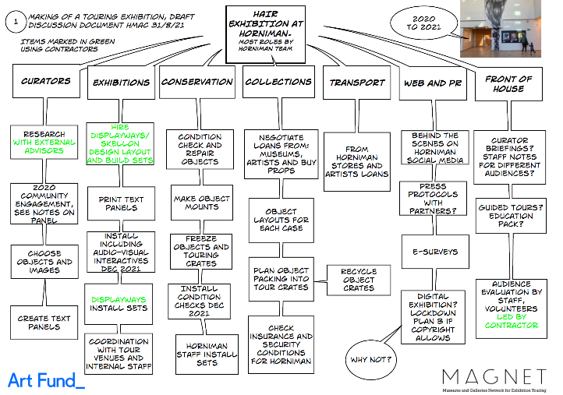Bringing further specialist skills into the process, such as additional interpretive skills to the Anthropocene group.

Figure 4 MAGNET Coordinator H. MacGillivray’s bubble diagram of roles and responsbilities within the pilot exhibition development for the internal Horniman Museum and Gardens team.

In light of the pandemic’s impact upon the sector and on partner capacity, MAGNET partners decided to draw on exhibition planning that MAGNET partners (especially the Horniman Museum and Gardens, see bubble diagram) had already undertaken prior to the Covid-19 lock-downs.

In this way, a feasible (and manageable) exhibition with which to pilot the MAGNET concept was identified – Hair: Untold Stories.

**Delivering an inaugural exhibition**

Much of the preliminary planning for an exhibition about hair had already been undertaken by MAGNET lead partner, the Horniman Museum and Gardens.

The theme was selected pre-pandemic but partners agreed that it is one that can unify people, be easily accessible for everyone and very pertinent at a time when ‘lock-down haircuts’, hair colours, identity and representation[25] have been high-profile topics in society and across social media. The theme of hair poses thought-provoking questions around cultural and gender identity, and provides many opportunities for learning.

The exhibition was to be co-curated by Horniman staff (Lead Curator, Dr Sarah Byrne) with anthropologist Professor Emma Tarlo, Goldsmiths, University of London. Alongside the main exhibition are two other exhibitions exploring the theme of hair – these fall outside the scope of this evaluation.

The Horniman Museum and Gardens has not developed a touring show for many years and this project therefore required the team to work and consider content in new ways.

MAGNET partners due to host the touring exhibition were included in the planning process and there was collaboration across organisations. However, host partners felt that in future their input could be more focussed and result in more tangible impact on the final exhibition.

The finished exhibition was due to open at the Horniman Museum and Gardens in autumn 2021 but opening was delayed until 9 December 2021 (the show end-date was adjusted accordingly, to ensure the same length of run). The exhibition ran until June 2022 at the first venue, and will next tour to Museums Sheffield and Tullie House in Carlisle. This will give MAGNET a good geographical range, with different audiences on which to base this pilot. Each venue’s exhibition is being accompanied by a public programme led by artists and communities aimed at engaging wider audiences, and an education programme targeting formal education institutions.

The exhibition has been designed so that each partner venue can weave their own collections into the exhibition content, and devise a programme that is relevant for their local and regional communities.

**‘Charlotte Mensa, who is one of the best Black hairstylists in the UK, she came in to do a Q&A with the general public. About 40 people came to that, a payable, ticketed evening event. We talked about themes, personal stories… It was very much welcomed by the attendees and by us.’**

**Community collaborator**

Flexibility for place-based content has been designed into the exhibition in some areas. This will be a useful tool to enable touring hosts to include content relevant to their local communities and target audiences.

**‘We plan to identify areas of the exhibition where the content is quite London-centric and amend that to content that is more relevant to us here.’ Stakeholder**

Additional provision for local tailoring of content or additions could be made in future exhibitions, especially where they are exploring topics pertaining to identity that may vary with local demographics and regional culture. There is also potential to provide host venues a worked-up programme, trails and education offer as part of the package that can, again, be tailored to their resources, audience profile and to complement their existing offer.

Covid-19 had an inevitable impact on the exhibition development process. Adaptive management by the team by flexing work processes allowed work to continue on the exhibition, within the limitations of restrictions.

The pandemic also created delays and interruptions to the continuity of both the exhibition development process and staffing, for example due to furlough, including the Lead Curator.

**‘I don’t think Covid has helped the process or the outcome. Lots of meetings have been done remotely, lots of changes in staff have happened, people were furloughed or redirected to work on other things.’ Stakeholder**

**‘The delays were largely due to Covid, I think. We started the discussion before Covid and then when we got the go-ahead we had to get going straightaway.’  Community collaborator**

However, on balance the MAGNET and exhibition development team succeeding in continuing partnership-working and exhibition development in the face of multiple Covid-19-related challenges represents a great success for the pilot and a sign of the professionalism and determination of the team.

Developing an exhibition through the MAGNET network has brought additional benefits, such as leveraging resources and cost-savings.

**‘There have been some clear benefits. When we visited the Horniman, the MAGNET investment has made certain things that will tour well. The benches and the Perspex cases and so on, they have been able to do that because of the MAGNET connection and that will save us thousands of pounds and will enable the tour to have that shared identity.’ Stakeholder**

There are likely to be additional cost savings possible for future exhibitions, for example through procurement.

**‘We would advocate for less use of London-based suppliers. We feel we could have got better value from a non-London contractor.’ Stakeholder**

**Creating an object-rich exhibition**

Hair: Untold Stories was always intended to be an object-rich exhibition. It was able to draw upon ethnographic and social-history collections to select objects that created intellectual ‘gateways’ into fascinating but complex, and 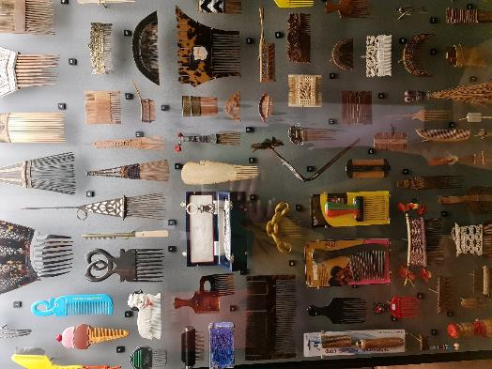often sensitive, issues around hair. This has given a richness to the story, added a layer of authenticity and brought a historical strand to the narrative.

Figure 5 Photo of comb display in Hair: Untold Stories. This exhibition element was a particular draw for Black visitors. It often prompted discussion within visitor groups, relating what they saw to their own lives and memories, and also inspired a few visiting groups to consider doing their own comb designs and 3D printing.

**‘It’s a good opportunity to bring objects to our venue that have been curated beautifully.’ Stakeholder**

In addition to using objects from the main museum collections, new objects and artworks were brought in via purchases (these were props for the exhibition), loans and commissions. This was a time-consuming process, especially in loans administration. Future MAGNET exhibitions would benefit from a streamlined approach to loans and practice can be drawn from organisations who regularly organise touring exhibitions. Due to the nature of the exhibition theme, the exhibition team also had to navigate the Human Tissue Act (2004), and items falling under the jurisdiction of the Act could not be used in the exhibition due to licensing issues.

Objects and artworks on loan need to be properly cared for and insured during the entirety of the touring period. This has both legal and reputational implications for MAGNET and the lead partner for the exhibition. Whilst this is relatively straightforward for the lead partner to ensure at their own venue, it becomes more complex when the exhibition goes on tour.

**‘The bureaucracy, the loaned items – that was tricky at times to agree how to display items; those technicalities were frustrating. At points we couldn’t find a compromise to insuring and displaying items. Some items were cheaper to buy from the artist than take on loan for insurance purposes. That was frustrating.’  Stakeholder**

**Exhibition design**

External exhibition designers[26] were commissioned to work on the exhibition, and also inputted to branding and marketing. The appointed 3D designers subcontracted 2D design to another agency, which in hindsight complicated the process for the client.

The internal design team at the Horniman Museum and Gardens (which is a one-person team) did the vast majority of the artworking of the graphics and printed all internal captions in-house. The expertise of the workshop team was utilised in making the majority of mounts in-house. Lighting design was also completed internally. This internal work meant the quality of final exhibition was feasible on a smaller cash budget but these costs or Full Cost Recovery for this time should be factored into future projects.

Commissioned illustrations were also added, which now form an integral part of the look and feel of the exhibition and add significantly to the finished product. This process worked but complicated the project management, design development and sign-off.

This process generally worked well; however, there are several areas where the process could have been improved, for example:

* There was confusion over where the client/internal design team responsibilities and external designer responsibilities lay. Further detail on required roles could usefully be included within future briefs, and building on this, more time for discussion of roles and responsibilities should be undertaken during the commissioning phase.
* The client team felt that there could have been more coherent full working 2D- and 3D-designs
* Whilst discussions about interactive elements to the exhibition were had in the early stages of the commission, interactives were not holistically included in designs and had to be retrofitted by the client at a late stage
* As above, family were a secondary audience and needed consideration within designs; however, this was an area that could have been improved. A regular quality check of plans against intended outcomes and audiences would have helped to flag this up earlier in the process
* Whilst there was extensive consultation around the concepts for the exhibition, including a panel specifically focussed around Black Hair, audience testing of concepts and content could have been better factored into the external design team timeframes. Ideally, for future exhibitions, this would be budgeted for and included within the external design brief, with a clear link to milestone payments.

A greater focus and support for relationship management (between the client and external design contractor) and risk management (of the contract) would be beneficial for future projects, to iron out some of these issues. These learning points can also inform the agendas of scoping meetings for future design commissions and for attendance, for example bringing learning and engagement colleagues into the process at an early stage[27] to act as audience advocates and to bring expertise in encouraging interaction.

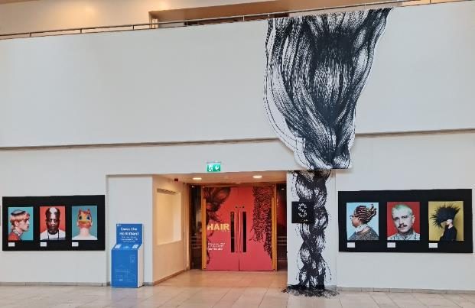

Some of the 3D and 2D design is very specific to the Studio Gallery layout, and future exhibitions could have more generic design consideration or include budget for bespoke design elements for each host venue. The design process would be aided if tour venues were able to provide dimensions and plans for intended spaces for the exhibition early in the process. Overall, the finished product is a high-quality exhibition with excellent-quality design, mindful curation and imaginative object display.

Figure 6 Photo of the entrance way to the Hair: Untold Stories exhibition at the Horniman Museum and Gardens, including the additional illustrations commissioned to add to the 2D design and Cult Hair exhibition photos from Infringe.com

**Community collaboration and co-production**

The relevance of hair to a wide range of people and to contemporary narratives around identity, gender and self-expression made it an appropriate topic for community co-creation and co-curation.

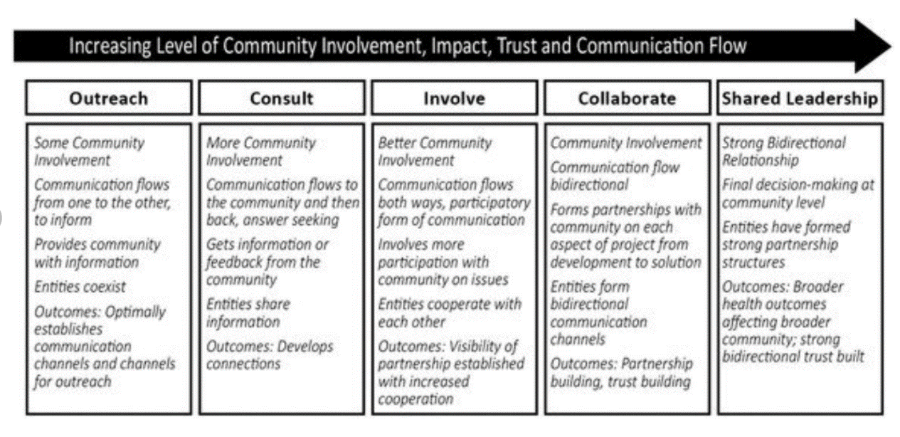

Figure 7 Community Engagement Continuum, developed by the Clinical and Translational Science Awards Consortium (2011).

**‘Hair is so familiar to us that we rarely stop to think about what an extraordinary fibre it is.’ Extract from exhibition marketing**

The exhibition development team recruited 20 people from the diverse South London community to share their hair stories. The community fieldworkers met biweekly on Zoom to share their hair stories, learn about interviewing techniques and museum curation, and to meet artists and anthropologists who work with hair. In addition, the team worked with a range of artists and creative practitioners. The illustrator who produced illustrations that feature heavily in the exhibition visual story was originally recruited into the project as a community fieldworker.

Together, these external members of the exhibition development team are termed ‘community collaborators’ for the remainder of this report.

The community collaborators themselves were experts through lived experience, for example of living with a hair-related condition. Together, they brought more voices to the exhibition – not just their own but others within their community (geographic-, experiential-, professional- or interest-based community).

The level and nature of involvement of community members and creative practitioners in the process sat at various points on the continuum of community engagement, see diagram below. During the exhibition development process, this ranged from ‘Consult’ to ‘Collaborate’.

Having discussions internally, and with community collaborators, about the desired nature and level of partnership during the initial exhibition development process will help to ensure a mutual understanding of how community collaborators will be involved in the process, the level of commitment and how any content created will be treated. This would also allow adequate resource, expertise and time to be factored into the museum and contractor development team to ensure community collaborators can be supported to be involved at the agreed level in the process.

Community collaborators felt that the exhibition development process was inclusive and that diversity of opinion and voice was welcome.

**‘The fieldworkers felt like a diverse group and the team were great at being very inclusive. They gave us opportunity to raise questions and concerns, and in terms of ethnicity, gender ID and cultural background, it was very inclusive.’ Community collaborators**

The staff team worked hard to ensure a safe and welcoming environment for collaboration and contributions was established and maintained.

**‘The community engagement project that fed into the museum was done carefully, people felt involved and things developed out of other things, like the illustrator who was originally involved as a community fieldworker. Local people felt genuinely involved – that was good. That really showed at the opening also; we had people from all different backgrounds and organisations there to see their personal impacts and additions.’  Stakeholder**

**‘Sarah worked well with us. She wanted us to have autonomy, flexibility. I think that element was good.’ Community collaborator**

The exhibition development team navigated the opportunities presented by community engagement and co-production, for example bringing additional voices into the narrative, but also by the challenges, for example the sheer amount of time needed to involve and communicate with others in the already complex process of exhibition development.

**‘About a dozen different people have contacted me from the Horniman; they were asking for information, measurements and so on. That was a bit frustrating because at times they might misinterpret it or get it wrong, but it was in hard copy, so that was frustrating. I had to re-do some things for them several times. That’s a lot in my experience.’  Fieldworker**

Additional challenges were posed by bringing others into the iterative, ‘messy’ and often pressured process of exhibition development. where it can be hard for those new to exhibition development to see where the team is in the process, next steps, how decisions are being made and with whom ‘power’ lies, for example on editorial decisions.

There are inevitably lessons learnt from the process, for example external stakeholders and community collaborators found it hard to understand the exhibition development process and the model of consultation/co-production:

**‘It has always been unclear what the eventual aim was, and how much was envisaged as being a partnership. I think we understood it was a partnership but now it very much feels like a touring agreement but with extra work.’  Stakeholder**

**‘Some of the preparation could have been a bit smoother. There was a lot of back and forth; this was impacted by Covid, too. Sometimes delivery timelines weren’t very clear.’ Community collaborators**

Future co-produced exhibitions should mindfully create ways to give more visibility into the exhibition development process, for example through a staged work programme with key milestones that they are all involved in and can be visually presented in a simple diagram for ease of communication.

Community collaborators and stakeholders felt that there could have been more timely internal and external communication, and as a result there were misunderstandings that hindered progress for some.

**‘The museum communication at times was quite limited. It was easy to get set up but there were times when we didn’t hear from the team, things like when the exhibition would happen and when to put together our submissions.’** **Community collaborators**

The overall result of the exhibition process is a more authentic, relevant (see Section 2.4) exhibition than would have been developed by museums teams alone.

It is clear that community collaborators and partner organisations (outside of MAGNET) also gained significant outcomes from involvement in the process, including:

* Improved networks
* Confidence
* Artistic development:

**‘It has inspired me to have a solo exhibition. I have about nine years of content that I am sitting on. Now is the time to create that.’**

* Raised profile:

**‘I’m in the process of doing a Q&A with InFringe, a big hair magazine. They reached out to me and we did a highlight on me, my practice, my hair story and the exhibition. They are a huge hair-related platform for me.’**

* Follow-on actions such as taking the learning back into their own organisation and continuing personal learning:

**‘I would like to see my organisation include some of those areas of inclusion and diversity, to include hair loss for people of all backgrounds. I would like to continue learning more about the hair and hair trade.’**

* Economic benefit for SMEs

**‘The Horniman has become one of my stockists – they sell my prints in the gift shop.’**

**Community collaborators**

## **2.3 Hair: Untold Stories**

**Developing new and existing audiences**

Hair: Untold Stories is a high-quality, innovative exhibition that uses anthropological collections at its core to explore hair cultures around the world, including in the UK. It has created an opportunity for host museums to attract audiences as an ‘appointment to visit’[28] for some.

**‘Support museums & please share. Just been to @HornimanMuseum and was transfixed by “Hair: Untold Stories”. Museums are open. The “Hair” exhibition is OPEN until June 22. Go. Go. Straight of Afro.’ Visitor**

**‘While you can catch it, go see the Hair Untold exhibition at the @HornimanMuseum. Beautiful poems, images, videos, concepts…’ Visitor**

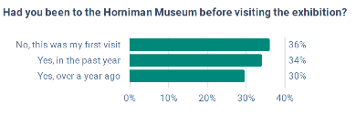

Figure 10 Bar chart showing the percentage of repeat visitation to the Horniman Museum and Gardens by exhibition visitors. N=340

An estimated total of 104,420 people visited the exhibition.[29] Around a third of visitors to the exhibition were new to the Horniman Museum and Gardens.

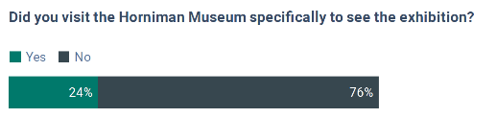  
Figure 11 Stacked bar graph to show the percentage of visitors who visited specifically to see the exhibition. N=333  
  
Just under a quarter had visited the Horniman Museum and Gardens specifically to see the Hair: Untold Stories exhibition.

The primary audience for the exhibition was adults,[30] with families[31] being a secondary target audience. The audience was strongly skewed towards female visitors (69%), with a quarter coming from Lewisham.

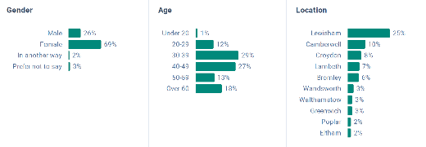

The Horniman Museum and Gardens had a specific objective to increase the percentage of Black and Ethnic Minority visitors to the exhibition space.[32] Figures on returned surveys put the percentage of Black, African, Black British or Caribbean visitors, for example, at just 10%, whereas observation within the gallery points to this figure being far greater – at least double that figure. There may be an issue with how representative the sample of people who responded to the survey is, indicating potential non-response bias.

The exhibition met or exceeded the expectations of the vast majority of visitors, both new and existing (N=39). For those for whom it didn’t, they said that they didn’t have any expectations (N=7).[33] 81% of visitors[34] said that they would definitely or very likely recommend a visit to the Horniman to a friend, family member or colleague.

**‘We are hoping it will diversify our audiences a bit. It will represent audiences that we can’t represent at the minute.’ Stakeholder**

**‘The Horniman were able to bring different audiences in, but the exhibition is more than that; it is a mixture of public engagement, choice of topic, choice of curators – it even boils down to who is employed in the museum as well as what the collection contains.’ Stakeholder**

**‘It will help us reach audiences that will want to see new exhibitions. It’s an opportunity to broaden the stories that we show here. The hair show has a broad appeal and is a real opportunity to show rare world cultural and historic items, but in a family-friendly, interactive show.’ Stakeholder**

The exhibition also created significant interest from schools wanting to visit. Of the 15 enquiries received, over half (eight) are from education institutions who have never visited the museum or have not visited in the last five years. One of these schools is Norwood School, Lambeth,[35] which brought two teachers and a group of Halo Collective Year 11 students and were observed during their visit. The exhibition provoked discussion amongst students and they wanted to take photos and post them on social media but couldn’t find a hashtag to use. The group spent a long period in the hair shop and barber’s shop.

The exhibition has resulted in the first joint exhibition team/education team school project in over 10 years. The project is a collaboration with Haberdashers’ Aske’s Knights Academy and Alix Bizet, material researcher, designer and educator.

There is significant opportunity to appeal to secondary schools, in particular, with the exhibition, through targeted marketing and an attractive schools offer.

The exhibition scored highly against each of the following Arts Council England dimensions:

1.Captivation – It held my interest and attention

2. Challenge – It was thought-provoking

3. Concept – It was an interesting idea

4. Distinctiveness – It was different from things I’ve experienced before

5. Relevance – It had something to say about the world in which we live

6. Rigour – It was well conceived and put together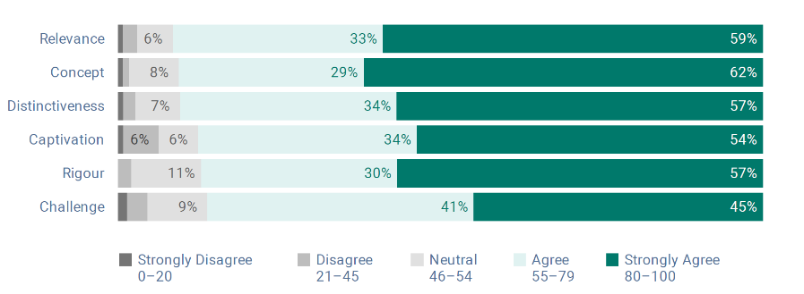

Figure 12 Stacked bar graph showing the percentage levels of agreement with each of the Arts Council dimensions.

**Delivering an inspiring visitor experience**

The average[36] visitor dwell time[37] was 17.8 minutes in the exhibition, with adult-only groups/individuals staying slightly longer (18.7mins) compared with family groups (17 mins). The longest recorded stay within the exhibition was 60 minutes, which is relatively high for such a small space, whereas the shortest was just one minute. Overall, relatively high dwell times were seen and excellent levels of engagement with content for the most visitors.

The exception was for families with young children (but not babies), where dwell times were lower than average and children were observed to move through the exhibition quickly, with little to catch their interest for anything but a fleeting length of time. The one point in the exhibition that consistently had a high dwell time for those with younger children was the handling table run by volunteers, when this was available.

These statistics mask the observation that family dwell times were much higher than average amongst families with just a baby rather than older, independently mobile children. Unsurprisingly, the family dwell time was governed by the attention span of the youngest visitor in their group, corresponding with a normal rule of thumb the evaluators see across visitor experiences. Some high dwell times were recorded for families with older children, and from observation, the multimedia nature of the exhibition added to the interest for these visitors.

The design, layout and content of the exhibition lent itself to a social and cognitive constructivist-style[38] visitor experience,[39] where visitors can dip in and out of content as they wish, and learn and shape ideas with others. Relatively high levels of social interaction between visitors within a visiting group were recorded within the Hair: Untold Stories exhibition. This included indicators of cross-generational learning in action and also discussion of key exhibition topics amongst visitors within the same visiting group.

There were several ‘hot spots’ within the exhibition, including:

* **Blond hair dress** **–** This artwork by Jenni Dutton was well placed near the entrance to the exhibition as a ‘wow’ object. Some visitors touched it (despite the signs) and others expressed a desire to touch it. Visitor groups often interacted with this exhibit, for example a young girl (4–5 years old) was observed comparing her own hair to the hair the dress is made of.
* **The animal hair touch table –** This was staffed by volunteers and was popular with visitors of all ages, but it specially added interest for families.
* **The hair shop –** This was not originally intended to be an interactive space, but it has become one of the stars of the show. Some visitors said they recognised the products and had used many of them.

**‘It’s not a hair shop without Eco. Have they got it?’ ‘Yeah, look…’ Visitors**

This space could have been even more interactive to support family visits. A zine[40] created by the hair shop curator and cultural producer Korantema Anyimadu was a takeaway product for visitors but there have been none printed nor available when the evaluators have been onsite. Similarly, a ‘wig trail’ was mentioned in one exhibit label but with no prompt as to how to follow it or what it includes.

* **The barber’s shop** – Visitors interacted with the content and each other in this space; sometimes discussing memories and experiences, sometimes role-playing and at other times listening to the content. This is an area where more role play for young visitors could have been encouraged, with child-safe barber’s implements.

**‘The barber’s shop – that felt really reminiscent.’ Visitor**

During behavioural observation, some visitors were observed to be confused and discussing what is art and what are museum objects within the exhibition.

The two additional hair-related shows on at the same time as Hair: Untold Stories added value and interest for visitors, especially Cult Hair, which was situated immediately outside the exhibition entrance and visited by many people before or after they visited the trial exhibition. Whilst survey stats indicate that 47% of visitors went to Intimate Archives on the balcony, two thirds of visitors interviewed did not know the show existed and where it was situated. There could have been better signposting from the main exhibition to the other exhibitions, and linked items in the permanent galleries.

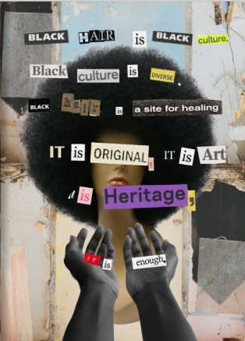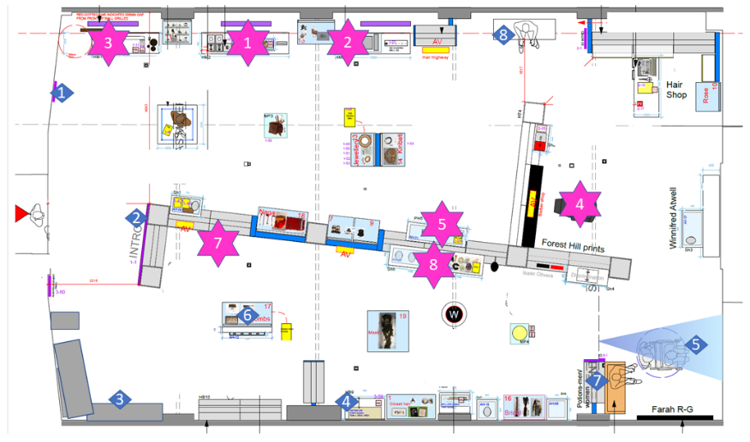[41]

Figure 14 Extract from the Hair Shop zine created by Korantema Anyimadu.

Figure 15 Gallery plan showing the elements that were most visited by visitors (pink stars, ranked 1-8 with 1 being the highest visited element) and least visited elements (blue diamonds, ranked 1-8 with 1 being the least visited element). Interestingly, there were no major differences in what was visited between family and adult only groups, with the exception of the handling table which was visited more frequently by families.

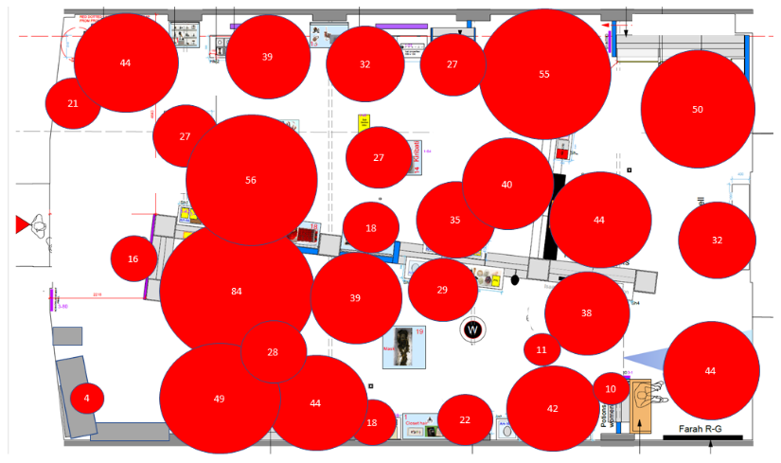

Figure 16 Heat map showing the average (mean) dwell time in seconds for each of the main gallery elements.

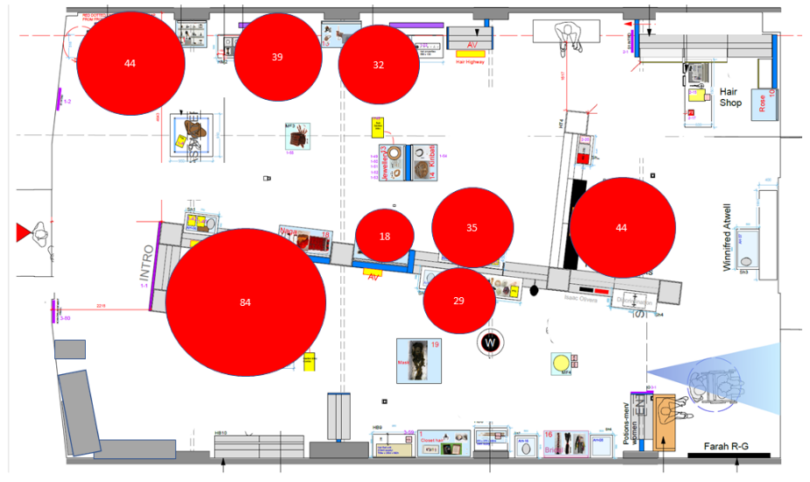

Figure 17 Heat map showing the average (mean) dwell time in seconds to the eight most visited elements in the exhibition.

**Finding relevance**

The art of finding relevance is central to a community-centred approach to museum and exhibition design.[42] Finding stories, choosing the way in which they are framed and told, and who tells the story, all impact upon the level of relevance for an audience.

Creating content and programming they are interested in or that is relevant to their lives (past and present experiences, and future aspirations) is crucial to widening audiences for arts, culture and heritage.

**‘Interpretation is a mission-based communication process that forges emotional and intellectual connections between the interests of the audience and the meanings inherent in the resource.’ National Association of Interpretation**

Hair: Untold Stories has short-circuited this process of finding relevance by taking a co-development and co-production approach to content development. Community fieldworkers and artists have brought in their own personal stories and those of others, and have presented them in interesting and thought-provoking ways, whilst the project team have brought in a wide range of perspectives and angles, ranging from religious significance to nature-based solutions to environmental issues. The choice of the topic of ‘hair’ is also pertinent as it is something humans can all relate to in some way.

The exhibition has successfully found relevance with a wide range of visitors by creating a contemporary and varied narrative that juxtaposes viewpoints and contexts. Four fifths of visitors[43] (N=43) said they found something that was relevant to them, with one fifth not finding anything relevant. However, one visitor made an important point:

**‘No, but learning about different hair is the point.’ Visitor**

The exhibition has been able to offer an exploration of issues important to individuals, such as identity, medical conditions and self-expression.

**‘It was brilliant to see hair explored through the lens of its environmental, cultural, economic, political, and not to mention emotional, significance. Would love to see more exhibitions of this kind.’ Visitor**

**‘I am proud to be raising awareness of hair loss to the general public. I think the exhibition is a good way to do that. The exhibition has brought in people who are interested in the Horniman Museum but it has attracted that audience to learn about hair loss and, more so, learning about the psychological and emotional impact of hair loss.’**

**‘I only came out to share my hair story with my friends two years ago. That was incredibly liberating. I’m incredibly proud of myself for that. It’s such a misunderstood condition that I’m happy portraying it in a positive light, raising awareness, normalising it for other people who are suffering.’ Community collaborators**

The Hair: Untold Stories exhibition has successfully found personal resonance with visitors. All visitors who completed the personal meaning mapping (as part of the evaluation process) were bringing their own thoughts, feelings, knowledge and lived experiences with them on their visit to the exhibition. This is well demonstrated in the comparison of resulting personal meaning maps on the broad topic of ‘hair’ before and after visiting the exhibition. Before visiting, people spoke mainly about hair as a method of self-expression, their personal experiences of daily doing their hair and important life moments involving hair.

Visitors included a surprising proportion of negativity in their discussion of hair before visiting the exhibition, using words such as ‘knotty’ and ‘never perfect’ to vocalise their struggle with their own hair. However, comments after the exhibition were resoundingly positive. For example, this shift is shown in the example from one visitor below:

Before: ‘[something] that I struggle with’

After: ‘I’m proud of my hair because some people don’t even have hair.’

A common trend emerged that is evidenced in all visitor groups and present in every visit. Visitors entered the exhibition with the context of their own hair at the forefront of their minds. The exhibition helped visitors to ‘scaffold’ or build on this existing knowledge, views and perceptions, and give them a new, or refreshed, more panoramic view of hair.

The content of the exhibition successfully helped all types of visitors to reflect and gain perspective on their own hair experiences, as well as to bring wider perspectives, life experiences, uses and significance of hair to others.

Although mental well-being was not a focus for the evaluation process or the interpretative plan, there are indicators within the evaluation evidence showing that the exhibition is likely to have been supporting positive mental well-being for some visitors. The interpretation does also include stories with a mental health aspect to them, such as the Open Barbers.

Ritual, meaning and religion were particularly prevalent in visitor evaluation post-visit. Whilst identity and self-expression featured heavily within pre-visit evaluation, by the time visitors left the exhibition these had been reframed in the context of a much wider perspective on what hair means to them and to others. Post-visit, some visitors also recalled personal connections to content, for example being a hairdresser, having strong childhood memories connected with content or memories of parenthood.

**‘This display was really wonderful and again reminded me a lot of childhood evenings with family friends cornrowing my hair.’ Visitor**

Some visitors also mentioned the exhibition’s link to contemporary issues, for example Will Smith’s outburst at the 2022 Oscars over Jada Pinkett Smith’s shaved head due to her alopecia areata condition.[44] This incident happened during the onsite research period for this evaluation.

A lesser-seen but pertinent reaction amongst a small number of visitors was that of disgust at someone else’s cut hair. This was such a strong reaction that individuals experiencing it struggled to engage with the content exhibition in any other way.

**‘Weird, disturbing (repulsive).’**

**‘Making a cake out of hair – that’s disgusting.’ Visitors**

These were, however, the only negative reactions to the exhibition collected or observed during the evaluation.

The very personal resonance of the exhibition with individual visitors can also been clearly seen in the comment cards left at the end of the visit, within the exhibition (see examples on following page). This element of the exhibition was popular with visitors, who spent time reading the comments of others. In future exhibitions there could be a further expansion of the opportunities for visitors to input their own comments and experiences into the narrative.

The inclusivity of the interpretative approach stands out as excellent practice. This is aided by the sheer range of different people whose stories are represented within the exhibition, from non-binary Black people, pet-hair knitters, eco-activists, global hair-traders and tribal peoples to Jewish women.

**‘When I went to see the exhibition, the depth of the breadth blew me away. The age range involved and represented was as diverse as the people involved, I think.’ Community collaborator**

**‘The exhibition was an interesting challenge, the outcome of which was generally inclusive but without privileging one group.’ Stakeholder**

There were a few issues regarding accessibility observed during the evaluation, namely:

* Low light-levels in the gallery making it hard for people to see exhibit labels and the contrast was poor in some of the design, e.g. white copy on pale pink is not high enough contrast to meet RNIB guidance for visual access and some font is small. For example, a Black woman visiting on her own was very interested in the exhibition and relevance to herself. She put her glasses on to read it but, when asked, said she found reading the text difficult in the light levels
* Light levels were also too low for some to take pictures, especially those particularly interested in the exhibition from an art and design perspective. Large-print, non-reflective copies of the exhibition text were not available but it would be easy to add these in a folder near the start of the exhibition
* Issues with hearing the audio via the audio points and a lack of transcripts available. These could be added retrospectively at limited cost
* Five of groups of adults with disabilities (learning and physical) and their carers/teachers were observed entering the exhibition space. They were looking for free things to do in the museum (they therefore didn’t want to go to the paid-for Cats and Dogs exhibition) and wanted to engage with the exhibition, but dwell time was low for all of these groups and they did not find content to keep them within the space.

# 3. Summary of lessons learnt and recommendations

The recommendations in the table below have been developed by the evaluators, taking into consideration the ongoing needs and aspirations of MAGNET and the potential for future exhibitions, the opportunities the partnership has created to date, changed context as a result of the Covid-19 pandemic, those most prevalent and pertinent within staff input[45] and professional experience of the sector. In particular, facilitated sessions using a reflective practice framework[46] with the exhibition team, and MAGNET partners helped to understand what happened, why this matters, and what should happen next.

| Area of trial and page no. | What happened? | Why does this matter? | Evaluator’s recommendation (EV) |
| --- | --- | --- | --- |
| MAGNET network development  Page 12 | The trial has built the resilience of the network and provided a space to collaborate ambitiously on projects that will deliver organisational goals shared across partners, for example diversifying audiences. | One of the aims of the pilot project was to Build capacity by developing ways of working, trust and understanding across organisations and teams.  The project has contributed toward this but also identified further work that can be done to ensure MAGNET is an effective and efficient tool for partners. | **EV1 Make space and dedicate resource to further develop the MAGNET network to help support museums** – MAGNET can benefit partner museums and the wider sector in meaningful and significant ways. However, to function effectively, further investment is needed to ensure a framework for developing, managing and hosting touring exhibitions is in place:   * **Ensure the governance structures are fit for purpose** * **Create a final Touring Exhibitions Strategy** * **Build a toolkit for developing and managing MAGNET touring exhibitions** * **Undertake a Skills Needs Analysis to inform a CPD programme** * **Ensure policies and protocols are in place.**   In addition to the above, if partnership-working is central to MAGNET’s unique offering, time should be set aside to develop this aspect of the network and external expertise brought in if required.  A small network-resilience grant would be ideal to support this work or it could be integrated into a wider project. |
| Exhibition concept development  Page 10 | Three concepts have been developed by MAGNET partners for potential development into touring exhibitions.  A community collaborator has also proposed an exhibition on the high-profile topic of the menopause,[47] which they have already done significant research into. They would like to discuss with MAGNET for potential as a touring exhibition. | All of the concepts represent viable touring exhibitions and, if taken forward into production, will encounter some of the same issues as Hair: Untold Stories. It is therefore important to ensure the lessons learnt from the trial exhibition development are integrated into the development process for any future exhibitions. | **EVR2 Define the model for each exhibition** – During development there are six key questions to help define the approach for individual future exhibitions. Answering these will help agree the most appropriate model:  **Q.** What model of touring exhibition development is appropriate? For example co-developed or developed by an individual organisation and offered for tour  **Q.** Which economic model do we want to use?  **Q.** What level of community engagement and/or co-production should we be aiming for?  **Q.** How will other contributors, such as artists and creative practitioners, be involved?  **Q.** Will local tailoring of exhibition content and programming add value for host museums? And what percentage of the package could be bespoke for the host museum?  And then consider:  **Q.** Have we costed, and then resourced, the exhibition appropriately to deliver our desired model?  These questions should be discussed during exhibition development. If the desired model of community collaboration is likely to sit within the ‘Collaborate’ or ‘Shared Leadership’ categories of the Community Engagement Continuum (see Section 2.2), then community stakeholders should be included within this discussion process. |
| Exhibition development process  Page 10 | The development of the trial exhibition has tested several ways of working. | The process has been a learning journey and produced many practical lessons learnt that can be integrated into the development of future exhibitions and also reflected in a MAGNET Touring Exhibitions Strategy (see EV1) | **EV3 Refining the exhibition development process** – lessons learnt from the trial exhibition development process, include the following:   * De-risk ‘churn’ in exhibition development team and host organisations, for example, keep a project diary which can help to onboard new staff into a complex iterative process such as exhibition development more quickly (page 13) * Secure and maintain input from Learning colleagues from the start of the process (page 13) * Bring external facilitators and expertise into the concept development process, where this will add value (page 17) * Enhance the ability of host museums to ‘personalise’ the exhibition to their location, for example, with more opportunities for place-based content, layout flexibility and programming (page 18-19) * Review procurement processes to ensure value-for-money (page 19) * Cost in all design work (even if being undertaken in-house) to exhibition cost model and associated grant applications (page 21) * Ensure a greater focus and support for relationship management with key suppliers (e.g. 3D and graphic designers) and risk management of their work flow (page 21) * Work with community collaborators to develop a mutual understanding of the nature of collaboration and key processes such as content editing (page 23) * Find ways to communicate the complex and iterative nature of exhibition development simply to community collaborators, for example, through a diagram (page 24) * Consider enhanced programming and education/engagement offer to accompany the exhibition and make the most of the audience development opportunities it creates (page 28) * Review sightlines during the design process to ensure all key elements will catch the eye of visitors (page 31) * Further consider accessibility during the development process, for example, transcripts for audio and visual content, mitigation for low light levels etc. |
| Impact measurement Page 5 | External evaluators were appointed to evaluate the project in the latter stages of its delivery and once the exhibition development process was complete. | External capacity and expertise were brought into the project, which was useful for investigating the difference the capacity-building and pilot project has made. However, bringing the evaluator in at the latter stages meant it was unable to build a narrative by observing the journey of the project and feeding in results at interim stage to help inform adaptive management. | **EVR4 Evidencing impact** – Integrate evaluation into future project proposals and exhibition plans. Appoint the evaluator early in the project delivery or even during development to allow them to observe and collect data along the whole journey of the project. Capacity can be extended by recruiting volunteers to collect additional data and be involved in analysis if they would like to.  The next funded touring exhibition proposal should include provision for development or adaptation of evaluation tools that can form part of the MAGNET Toolkit (see EVR1).  A formal evaluation of the network’s activities should be undertaken on a triennial basis and evaluation should be integrated into the resourcing for each exhibition. |

# 4. List of Appendices - For internal-use only

Appendix 1 Full list of key informant interviewees and interview framework

Appendix 2 CONFIDENTIAL Thematic analysis of telephone interviews

Appendix 3 Onsite tracking – raw data

Appendix 4 Vox pops, mini surveys and dwell time – raw data

Appendix 5 Examples of personal meaning maps – raw data

Appendix 6 Volunteer evaluator role profile

Appendix 7 Horniman Gardens and Museum report on visitors to Hair (21 December 2021 to 22 May 2022)

Thank you to everyone – all of the visitors, staff, volunteers, partners and community collaborators who contributed to this evaluation.

A special thanks to the volunteer visitor evaluators, Mengjiao Zhao and Edoardo Lena, for giving their precious time and bringing enthusiasm to collecting data 😊.

1. This term has been used to protect the anonymity of those interviewed to contribute to the evaluation, for example, where there is only one artist interviewed, it is not possible to label a quote from them as ‘artist’ without individually identifying them.
2. Estimated visitor figures for the Studio Gallery
3. As noted by the UK Evaluation Society and discussed extensively at its 2022 national conference.
4. Originally 12 but Birmingham Museums and Galleries’ involvement is on hold due to internally strategic development of the service and the demands of the Commonwealth Games, and Norfolk Museums left the partnership in 2020.
5. These volunteer roles were recruited and managed by the MAGNET Coordinator. Training in technical evaluation skills was provided by Heritage Insider.
6. Signed-off January 2022.
7. Reviewed at the 11th January 2022 Evaluation Lab 1.
8. Utilising a variety of methods of evaluation to build up a picture of a project
9. Triangulation is a technique that facilitates the validation of data with the use of multiple sources
10. Project proposal to the Art Fund, Interpretation Plan and various iterations of planning documents
11. Using permanent people-counters at the Museum entrances. Horniman Museum and Gardens visitor segments have not been used in this report as these are not transferrable to other MAGNET partner museums.
12. 8,311 surveys sent 6 Dec 2021–21 Feb 2022. N=340 responses
13. 4 March 2022
14. Undertaken by evaluation volunteers 1st, 8th, 22nd and 29th April 2022
15. 29th March and 11th April 2022
16. N= 14 completed over 2 days
17. Conducted by Heritage Insider staff and evaluation volunteers. N= 88. 46 vox pops and 22 mini surveys
18. N=7 with a range of external partners, artists, collaborators and community fieldworkers – see Appendix 1 for full list of interviewees
19. Pilot exhibition reflective session 1st March 2022 via video conference with project team, attended by: Adrian Holloway, Alistair MacKillop, Charlotte Ridley, Cressida Diex-Finch, Hamish MacGillivray, Julia Gresson, Kerstin Doble, Laura Davidson, Natasha Logan, Nick Budden, Sarah Byrne, Stewart Leather, Thomas Whitbread. MAGNET partnership 2nd March 2022 via video conference with partners, attended by: Anna Smalley, Cressida Diez-Finch, Georgina Young, Hamish MacGillivray, Holly Morgenroth, Nick Merriman, Katie Morton, Sarah Cook
20. *Going Places: Touring and shared exhibitions in the UK* (2022), Art Fund in partnership with Creative Scotland
21. A term used by independent researcher Dolores Beasley at the Visitor Studies Group conference, 2022.
22. https://touringexhibitionsgroup.org.uk/research-resources/ete/the-economics-of-touring-exhibitions/toolkit-developing-an-economic-and-production-strategy-for-touring-exhibitions/
23. https://touringexhibitionsgroup.org.uk/research-resources/manual-touring-exhibitions/
24. Photo credit: Miss Lesbian VII, Amsterdam, 2009, Zanele Muholic -print, 86.5 x 60.5cm, Walker Art Gallery, National Museums Liverpool, purchased with Art Fund support in 2017. © Zanele Muholi. Courtesy of Stevenson, Cape Town/Johannesburg and Yancey Richardson, New York.
25. For example, the Black Lives Matter (BLM) movement forced the UK, in the midst of a global pandemic, to stop, pause and assess one of the most pervasive, systemic issues we face: the representation of People of Colour in a white-dominated society. Whilst BLM is specifically about the treatment of Black people, in the UK it has brought under the microscope something which, as stated, many people have been looking at and addressing day in, day out, for decades: how groups of people, based upon their personal heritages, are minoritized, are represented, and how their feelings about their own identity are shaped by society. Groups such as the Halo Collective (https://halocollective.co.uk/), included within the exhibition, are an example of a reaction to this process and create a supportive environment where young People of Colour feel that they can wear their hair how they want, including naturally.
26. Main contractor: Skelen Studios, subcontracting to Seeing Things for 2D design
27. Members of the Learning team were part of the Hair: Untold Stories exhibition development process but this was hampered by furlough of some staff, for example.
28. ‘Appointment viewing’ and ‘Appointment listening’ are terms within the TV and radio industries to describe a show that is high-profile and drives audiences to make a point of viewing or listening to catch it.
29. Actual and estimated numbers for the period spanning 4th December 2021 to 31st May 2022 (see Appendix 7 for further details)
30. The aim was to attract more adult audiences, specifically Cultural Enthusiasts and Self-Improvers, with an aim to increase those visiting solo or in adult groups (our non-family audience). Increasing from a baseline of 29% (2019-20) to 40%.
31. The primary family audience for the museum tends to fall into its categories of Active Achievers and Social Sharers.
32. Increasing from a baseline of 18% visitors (2019/20 figures) to 25% for the exhibition – to be measured as part of the annual museum survey.
33. Total sample of 46
34. N=303
35. This school has an above-average percentage of pupils eligible for free school meals (24.6% against a national average of 20.8%). It is a multicultural, diverse secondary school with Black African students making up 23.4% of Lambeth’s school population (‘Language Diversity in Lambeth Schools’, Lambeth Council, 2018).
36. Mean average, rounded up to the nearest 1 decimal place
37. Calculated per visitor group
38. Narayan, R., Rodriguez, C., Araujo, J., Shaqlaih, A. and Moss, G. (2013), ‘Constructivism—Constructivist Learning Theory’, in The Handbook of Educational Theories (ed. Irby, B. J., Brown, G., Lara-Alecio, R. and Jackson, S.), Information Age Publishing, 2013.
39. Hein, G. E. (1998), *The Constructivist Museum.* Taylor and Francis.
40. https://online.fliphtml5.com/wnmuc/scjy/#p=1
41. N.B. Whilst the handling table appears on the least visited elements, it was not always staffed. When it was operational then it was one of the most visited elements in the gallery with a high dwell time, especially for family visitors.
42. Simon, N. (2016), *The Art of Relevance.* Self-published online.
43. N=56
44. https://www.bbc.co.uk/news/uk-wales-60911604
45. Source: client scoping meeting and project learning reviews
46. Adapted from: Rolfe, G., Freshwater, D., Jasper, M. (2001), Critical Reflection in Nursing and the Helping Professions: A User’s Guide (Basingstoke: Palgrave Macmillan)
47. ‘I’ve been developing an exhibition for the best part of a decade, on the subject of menopause. I have made this exhibition and I would be interested in speaking to the MAGNET partners about. It is going on display at the end of this year and the intention is that it tours.’ Community collaborator