

# Accessibility Guide for Horniman Museum and Gardens

[enquiry@horniman.ac.uk](mailto:enquiry@horniman.ac.uk), [020 8699 1872,](tel:020%208699%201872) horniman.ac.uk

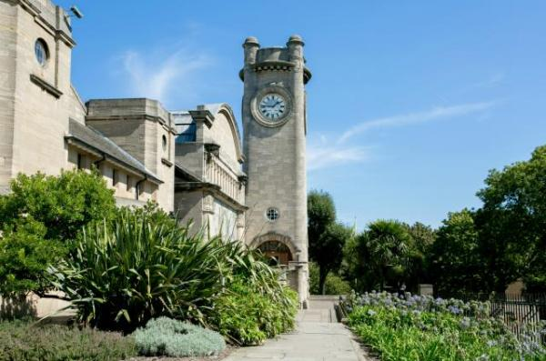

## Welcome

Founded in 1901, the Horniman Museum and Gardens is home to extraordinary collections of natural history, anthropology and musical instruments, as well as an acclaimed Aquarium, Butterfly House and 16 acres of beautiful gardens.

Visitors of all ages can also enjoy a year-round programme of inspiring exhibitions, activities and events. Visit [horniman.ac.uk](https://horniman.ac.uk/) to find out more.

## At a Glance

### Level access symbol Level Access

* There is level access from the main entrance to:
  + Natural History Gallery
  + Music Gallery
  + Aquarium
  + Studio
  + Temporary Gallery
  + World Gallery
  + Cafe
  + Ticket Desk
  + Cafe Toilets
  + Gardens Toilets
  + Gallery Square Toilets
  + Shop
  + Entrance Area
  + Horniman Gardens
* There is level access from the car park to:
  + Bandstand terrace and Dutch Barn

### Visual symbol Visual

* Glass doors have contrast markings.
* Some parts of the venue have low lighting.

### General symbol General

* We have a complimentary ticket policy for companions of disabled visitors.

## Getting Here

100 London Road  
Forest Hill  
London  
Greater London  
SE23 3PQ

### Travel by public transport symbol Travel by Public Transport

* You can get to Horniman Museum and Gardens by bus and train.
* The nearest bus stop is right outside the main London Road entrance. The stop is called 'Horniman Museum'. It is served by bus services 176, 185, 197, 356 and P4. The bus stop is 0.10 miles / 161 metres from Horniman Museum and Gardens.
* The nearest train station is Forest Hill. The train station is 0.4 miles / 0.6 km from Horniman Museum and Gardens.
* Forest Hill is served by mainland and overground services. There are signposts to the Horniman from the Platform 1 exit. It's an uphill walk of approximately 870 yards, or two stops on the bus. The 176, 185, 197 bus leaving from outside the 'Capitol' pub go to the Horniman.
* You can get a taxi with Forest Hill Radio Cars by calling 020 8291 1111.

### Parking symbol Parking

* There is a drop-off point at the main entrance. The drop-off point does not have a dropped kerb.
* There are limited spaces for car and mini-bus parking available on the Horniman site for Blue Badge holders on a first come, first served basis. Please arrive via Horniman Drive gate. There is a buzzer on the right-hand side, please press it to ask Security to enter. If the buzzer is too high, please call 020 699 1872 – Option 6. There is a downloadable pictorial guide available on the Horniman website.

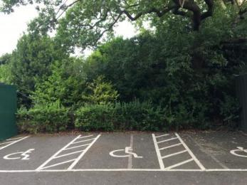   
 Blue Badge Parking

## Arrival

### Path to main entrance symbol Path to Main Entrance

* From the street to the main entrance, there is level access.
* The path is 1210mm wide, or more.
* The path from the main gate to the Museum entrance is approximately 150 meters long and is uphill. There are benches along the route. The main entrance is to the right.

### Main entrance symbol Main Entrance

* The main entrance has level access.
* The main door is sliding and automatic.
* The door is 1460mm wide.
* There are two sets of automatic glass doors at the entrance.
* It can get busy and noisy in the entrance area. Staff, identifiable by a yellow lanyard and dressed in black, are happy to help.
* The Ticket Desk is on the left and the Shop is on your right as you enter.
* Access to the Café, public lockers and additional toilets is via the Café terrace towards the left of the main Museum entrance.
* The Butterfly House and the Animal Walk are located in the Horniman Gardens, approximately 100 meters uphill from the entrance.

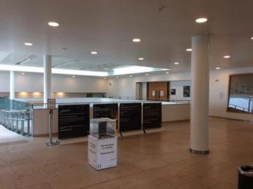   
 Horniman Foyer

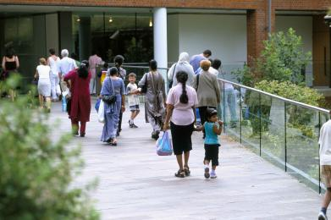   
 Horniman Entrance (photo by Caroline Hughes)

## Getting Around Inside

### Visual impairment - general information symbol Visual Impairment - General Information

* We have contrast markings on glass doors.
* Some parts of the venue have low lighting.

### Lift symbol Lift

* We have 2 lifts.
* You can get a lift to all floors.
* Please note – our lift will be out of use from 15 May – 9 July. Level access can be reached via our North Hall.

### Main Lift

* The lift door is 1310mm wide.
* The lift is 1350mm wide.The lift is 2810mm deep.
* The lift buttons have raised numbers or letters.
* There are audible floor announcements in both lifts.

### Aquarium Lift

* The lift door is 1000mm wide.
* The lift is 1100mm wide
* The lift is 2100mm deep.
* The lift buttons have raised numbers or letters.

### Entrance Area

* From the main entrance to this area, there is level access. The door is 1460mm wide.
* The Ticket Desk is on the left when entering, and the Shop is behind on the right. There is a bench next to the 'Hands on Base' on the right.
* Access to the Café, public lockers and additional toilets is via the Café terrace towards the left of the main Museum entrance.

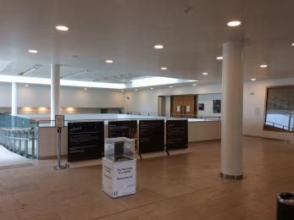   
 Horniman Foyer

### Ticket/information desk symbol Ticket / Information Desk

* Entrance to the Horniman Museum and Gardens is free. There is an admission charge to the Aquarium, Butterfly House, ticketed exhibitions and some events.
* Current ticket prices are available online [via the website](https://www.horniman.ac.uk/visit/buy-tickets), or directly from the Ticket Desk. Companions of disabled visitors receive a free ticket - simply let staff know, or choose the appropriate option online.

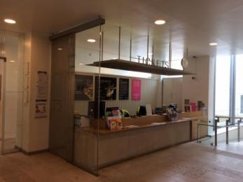   
 Ticket Desk

### Music Gallery

* From the main entrance to this area, there is level access. Some display information is low, for wheelchair users. There are seats.
* Some videos have subtitles.
* Adjacent to the Music Gallery is the Hands on Space, where visitors can try their hands on a number of instruments from around the world.

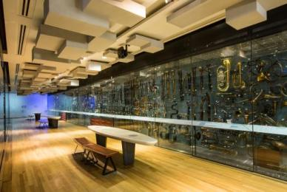   
 Horniman Music Gallery (photo by Sophia Spring)

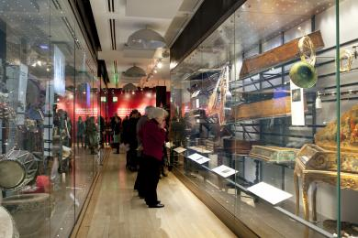   
 Horniman Music Gallery with visitors (photo by Ludo des Cognets)

### Aquarium

* From the main entrance to this area, there is level access. Some display information is low, for wheelchair users. There are seats.

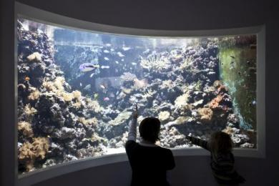   
 Horniman Aquarium (photo by Joel Knight)

### Temporary Gallery

* From the main entrance to this area, there is level access. Some display information is low, for wheelchair users. There are seats.

## Public toilets symbol Public Toilets

### Cafe Toilets

* There is a public toilet for disabled visitors.
* From the main entrance to the public toilet, there is level access. The toilet door is 760mm wide.
* The toilet seat is 470mm high.
* The cubicle includes a baby change. There is space to park a chair alongside the toilet. The wash basin is 470mm from the floor and has a swivel tap. The cubical is well lit. There are grab rails near the toilet.

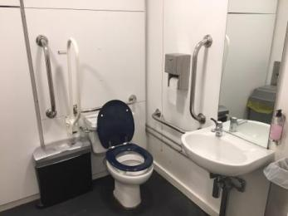   
 Cafe accessible toilet

### Gardens Toilets

* There is a public toilet for disabled visitors.

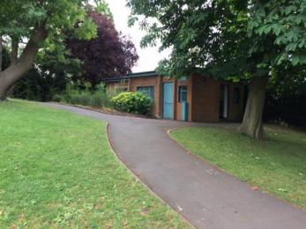   
 Path to Gardens toilets

* From the main entrance to the public toilet, there is a slope.

### Gallery Square Toilets

* There is a public toilet for disabled visitors.

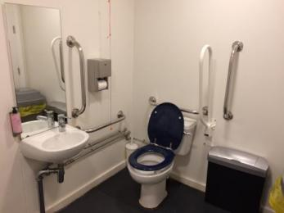   
 Gallery Square accessible toilet

* From the main entrance to the public toilet, there is level access.

## Shop symbol Shop

* From the main entrance to the shop, there is level access.The route through the shop is 800mm wide, or more.
* The counter has a wheelchair accessible area. Some items are displayed on higher shelving. There is always a member of staff to assist. No music is played in the shop.

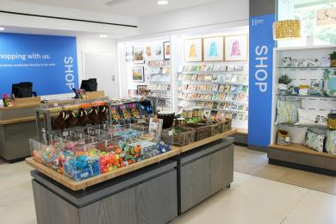   
 Horniman Shop

## Places to eat and drink symbol Place to eat and drink

### Horniman Cafe

* From the main entrance to the dining area, there is level access. The route is 8800mm wide, or more. The door is 8800mm wide.
* To get to a table, there are no steps.
* The dining area is self-service. The route through the dining area is 800mm wide, or more.
* There is background music sometimes.
* We cater for sugar free (diabetic), vegetarian, gluten free (celiacs), lactose free (dairy free), nut free, low fat and low potassium specific diets.
* Only food and drinks purchased at the Horniman may be consumed in the Cafe, but we do have a covered area in the Gardens, the Dutch Barn, where everyone is welcome to eat packed lunches. The Dutch Barn is located approximately 100meters from the main entrance.

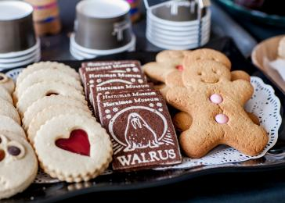   
 Horniman Cafe (photo by Sophia Spring)

## Getting Around Outside

### Horniman Gardens symbolHorniman Gardens

* From the main entrance to the Gardens, there is level access.
* The route is 1210mm wide, or more.
* A downloadable map is available from https://www.horniman.ac.uk/visit/floorplan. The Gardens have concrete paths throughout. Some of the paths are uphill and have bends. Please note that some of the paths are very steep. The main large pathway towards Horniman Drive gate has speed bumps. The Sunken Garden and the Grasslands Garden are accessible via wooden gates closed by a metal clasp at the top. There are many wooden benches alongside the paths. There are also picnic-style benches and tables near the Bandstand on the terrace area. The Gardens have public toilets, including one accessible toilet.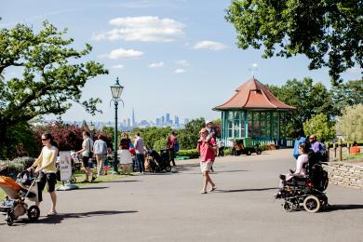   
   Horniman Gardens (photo by Sophia Spring)

## Picnic area symbol Picnic Area

### Bandstand terrace and dutch barn symbol Bandstand Terrace and Dutch Barn

* From the car park to the picnic area, there is a slope. The entrance is 1210mm wide.
* Some tables have space for wheelchair users. You can bring your own food to the picnic area.
* The tables inside the Dutch Barn, have space for a wheelchair user, but not currently the picnic tables outside, on the Bandstand terrace.
* There is also a cafe nearby where food and drinks can be bought.

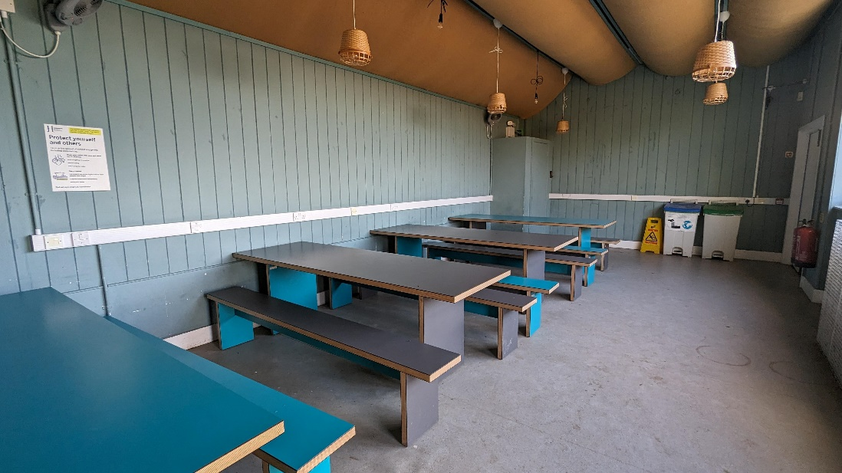   
 Dutch Barn seating

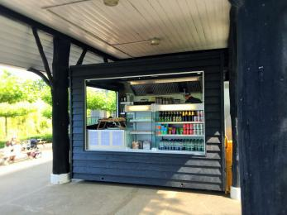   
 Dutch Barn cafe kiosk

## Customer Care Support

### Accessibility equipment symbol Accessibility Equipment

* We provide wheelchairs. Wheelchairs are free to borrow.
* Magnifying sheets, torches, pen and paper, can be borrowed from the Ticket Desk. Torches and Magnifying sheets are also available in the Music Gallery.
* A drinking bowl for assistance animals can be borrowed from the Ticket Desk.
* The nearest toilet area for assistance dogs is located within the Horniman Gardens, approx. 20 metres uphill from the main entrance.
* Although there is not a dedicated area where mobility scooters or battery powered wheelchairs can be charged, we are working towards this. Please ask a member of staff if required.

### Emergency Evacuation Procedures

* We have emergency evacuation procedures for disabled visitors.
* Frontline staff are trained in safely evacuating the building, and will direct visitors to the nearest exit or refuge area.

### Customer care support symbol Customer Care Support

* We have some information available in large print.
* To book a group visit, or to find out more about our community partnerships, please [visit our website](http://www.horniman.ac.uk/learn/visiting-as-a-community-group).

Guide last updated: 18 June 2024