Creative Health Case Study: Recovery College and Horniman Therapeutic Artmaking and Object Handling Course
Summary information
Project Title: ‘Choose, Create and Learn Your Way to Recovery: Therapeutic Artmaking and Object Handling at the Horniman Museum’
Authors: Julia Cort, Art Psychotherapist, Horniman Museum and Gardens; Ursula Bowerman and Claire Lamy, Peer Trainers, South London and Maudsley Recovery College
Date: August 2025
Partners: South London and Maudsley (SLaM) Recovery College; Horniman Museum and Gardens (the Horniman)
Funders: Department for Culture, Media and Sport; South London and Maudsley NHS Trust; Maudsley Charity
Introduction
This partnership between SLaM Recovery College and the Horniman brought together 2 highly experienced Peer Recovery Trainers and a museum-based Art Psychotherapist to deliver an innovative 12-week course. In summer 2025, 13 Recovery College students from diverse backgrounds supported their mental health recovery by choosing objects from the Horniman handling collection and responding to them using art materials, prompted by recovery-focussed themes (for example, figure 1). This ground-breaking combination of recovery-focussed psychoeducation, art psychotherapeutic approach and object-based learning methodology addressed the vital individual, social and economic need to ensure meaningful recovery from mental ill health. By the end of the course, students’ feelings of hopefulness rose by 57% and they felt 64% more in control of their lives. One student said, “This course opened a portal for me - to creativity, connection, joy - but also made space for me to show up just how I am, without the need to mask or prove myself.”
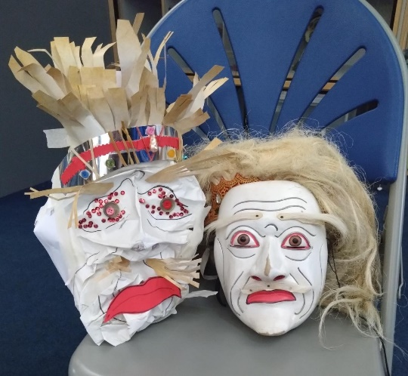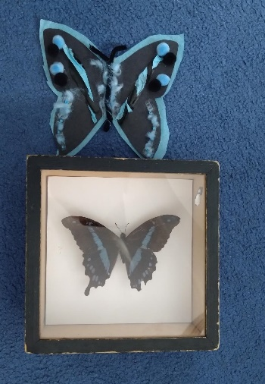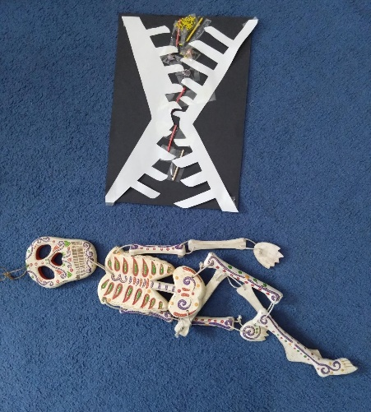
Figure 1: Students chose objects that symbolised an obstacle to their recovery. Their artwork helped them reflect on and begin to overcome that obstacle.

The Need
This project builds on three successful courses delivered together by SLaM Recovery College and the Horniman and is part of a Horniman pilot to understand the health impact of employing an in-house object-based Art Psychotherapist. The project addresses some pressing health and wellbeing needs. Recovery is as important as prevention in terms of enabling people to stay mentally well and lower the social and economic cost of poor mental health. This need is reflected in the strategic health priorities of South East London Integrated Care System (SEL ICS)4. Before starting the course, students were asked to identify their 3 most important health outcomes from SEL ICS and from SLaM Recovery College’s existing evaluation framework5 (figure 2).

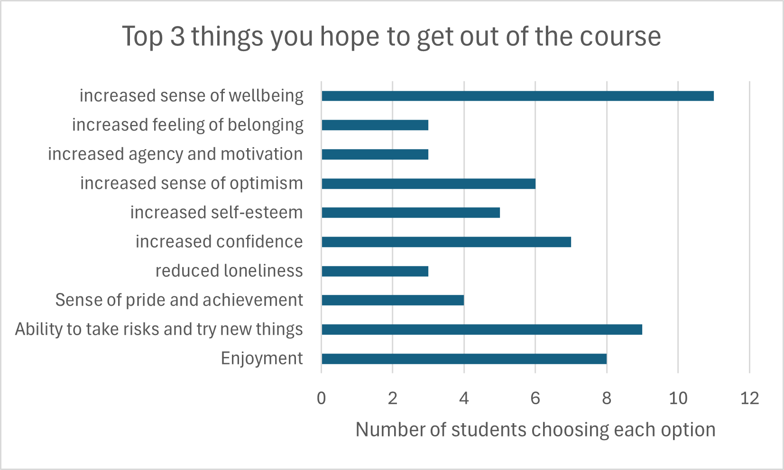
Figure 2: students’ hoped-for health outcomes (some students chose more than 3 options).
Students’ self-reported needs reflected their responses, with some reporting feeling “lonely in myself” and “very lost”.
The Approach
Between 7 May and 23 July 2025, a weekly 12-week course of 1.5-hour sessions combining recovery methodology with object-based learning and therapeutic artmaking took place in the Horniman object handling gallery: the Hands On Base.
The course costs included staff costs for two Peer Trainers (Recovery College) and one Art Psychotherapist (Horniman). Spaces were offered in-kind, and all materials were recycled from previous Horniman art & craft activities. Horniman branded stationery and free entry vouchers were offered to encourage independent visits to the Horniman.
In line with recovery college best practice, the course was co-designed and co-delivered by Peer Trainers with lived experience of mental ill health and an Art Psychotherapist experienced in object-based learning. This ensured a tailored approach and a range of expertise was available to students.1 The course focussed on creating a nurturing environment, using recovery-focussed language and ensuring students had opportunities to make choices and to connect with peers.5 Our training and qualifications ensured facilitators could provide an anti-discriminatory, trauma-informed and safe intervention. A partnership agreement ensured the smooth running of the course and a thorough risk assessment ensured the safety of participants and staff.
The course was advertised in the SLaM Recovery College prospectus. It was open to people over 16 who currently (or in the last six months) use SLaM’s mental health services. To allow for known drop-out rates, 16 spaces were offered, bookable online. The Art Psychotherapist contacted each booked student by phone prior to the course starting to provide further information and ask about any barriers to participating. This process highlighted those who could no longer attend and allowed their places to be offered to those on the waiting list. 13 students were recruited onto the course.
The first 2 sessions consisted of co-creating a group agreement and icebreaker activities to familiarise students with the course and each other. The 3rd session involved a walk in the Horniman Gardens and response artmaking. After this, the sessions followed a format of:
- trainers offering a recovery-focussed theme (see table 1)
- students choosing an object each from the 4,500 objects in the Horniman handling collection in relation to the theme and non-standard art materials that were permitted in the space (figure 3)
- students making artwork in response to the theme and their chosen object (for example, figure 1)
- group feedback: students sharing what they had chosen and made with each other if they wished.
session | Choose an object that…
4 | …symbolises recovery for you.
5 | …you might take with you to support you on your recovery journey.
6 | …symbolises an obstacle to recovery.
7 | …symbolises a moment of calm (Gardens-based).
8 | …symbolises an attribute (or attributes) you have that will help you on your recovery journey.
9 | …symbolises stepping outside of your comfort zone, and perhaps make something about how it feels after you have done it.
10 | Choose your own theme!
11 | …makes you feel strong.
12 | …symbolises your identity and vision for your creative self in your recovery.
Table 1: Session themes
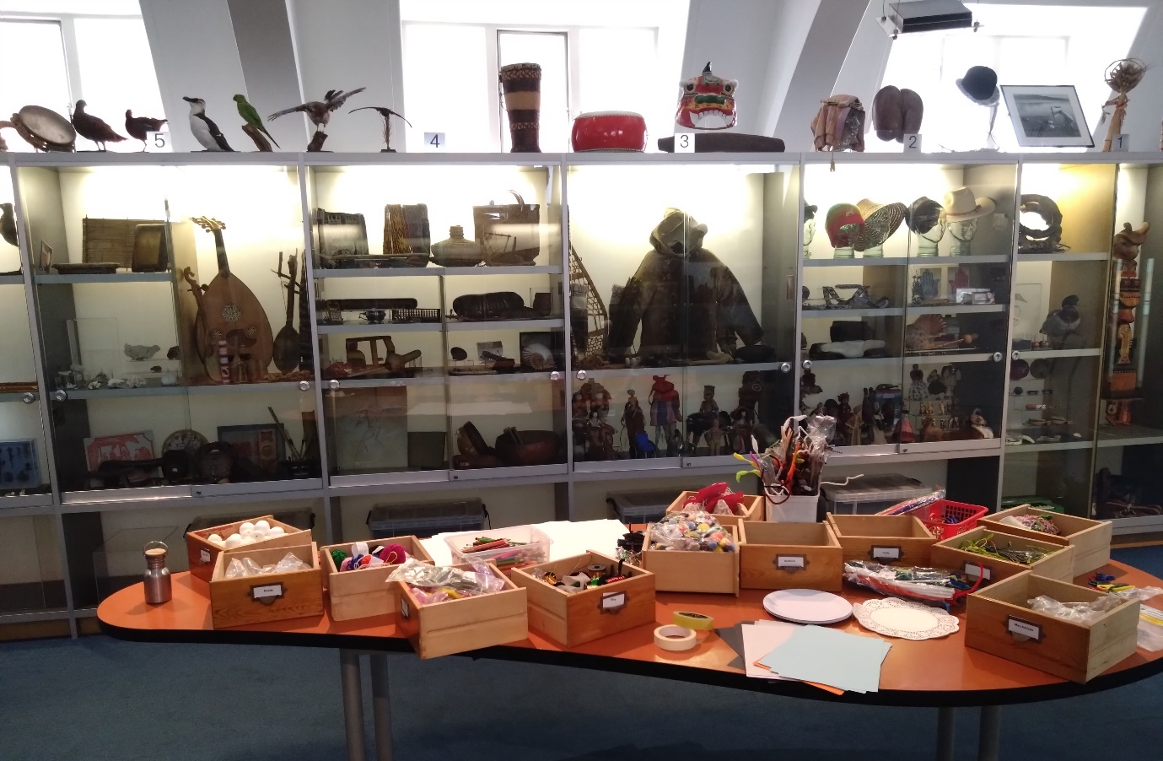
Figure 3: Handling objects and art materials in object handling gallery
On three occasions, we met in another Horniman location and used living and natural materials from the Horniman Gardens instead of handling objects. During these sessions, students had access to a wider range of art materials (see figure 4).
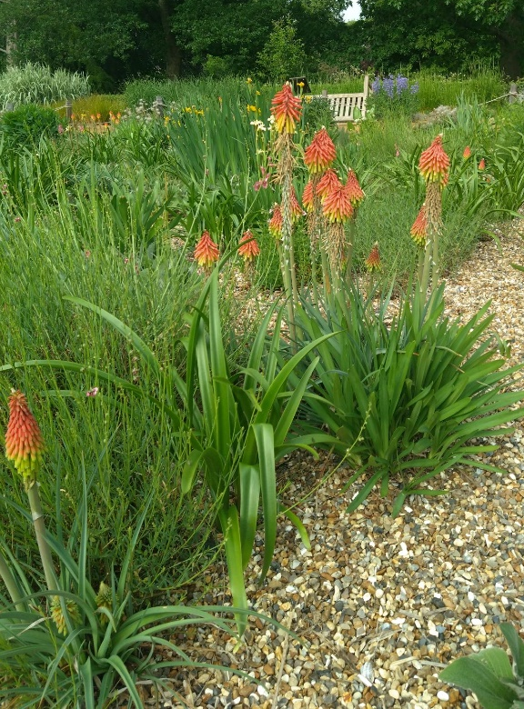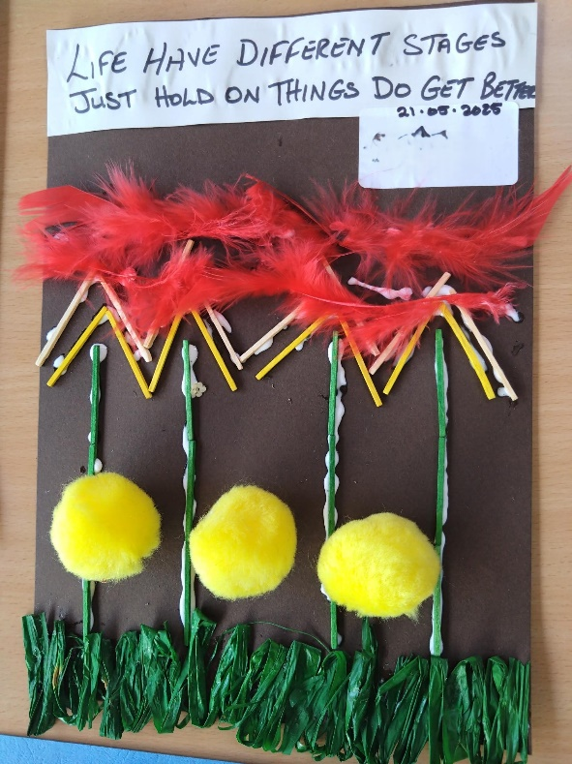
Figure 4: Example of student response from Gardens-based session

The impact
We evaluated using pre- and post-course questionnaires (Appendix 1). 2 of the 13 students attended 2 and 3 sessions respectively: one returned to work and one stated, “Life has been happening, yet open to attending when things chill out.”. The other 11 students achieved an average attendance rate of 83% across the twelve weeks. Post-course data was collected from the 10 students who attended the final session.
Ensuring meaningful recovery requires specialised recovery-orientated approaches.1 The SLaM Recovery College team are expert in these approaches and understand from people with lived experience that recovery requires factors including increased hope, control and opportunity. South East London ICS Neighbourhood Priorities echo patient need for control of their own wellbeing and access to opportunities within the community.
Students started the course with a relatively high average sense of hope, at 4.9 out of 10, which did rise to 7.7 by the end of the course: an increase of 57% (figure 5). One student explained how the course would help sustain this: “Being able to create things has been the missing link I now know I need to make space for in my life - I NEED to create to stay happy!”
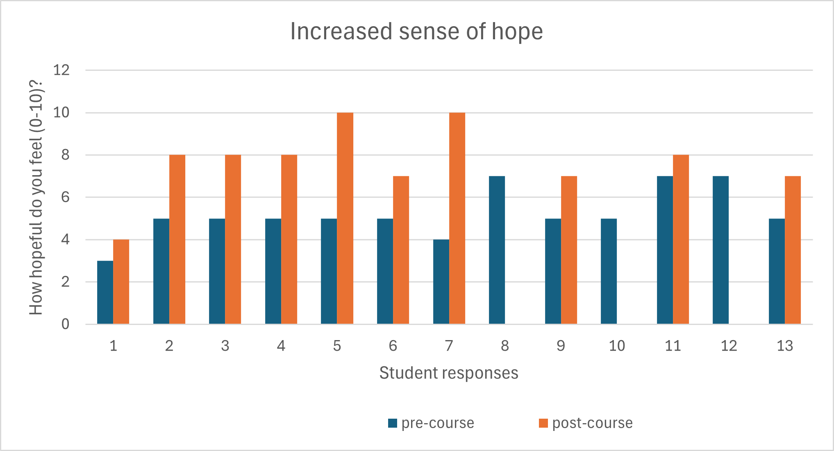
Figure 5: increased sense of hope
Students’ sense of being in control of their lives was the lowest of the 3 factors measured, starting the course at an average of 3.9 out of 10. This rose to 6.4 by the end of the course, an average increase of 64% (figure 6). One student explained that the course, “Helped me to problem solve (without glue and perfectionism habits) so increased my confidence to adapt and pivot.” Another student said that, as a result of the course, “I can talk to someone without panicking and I now go outdoors more.”
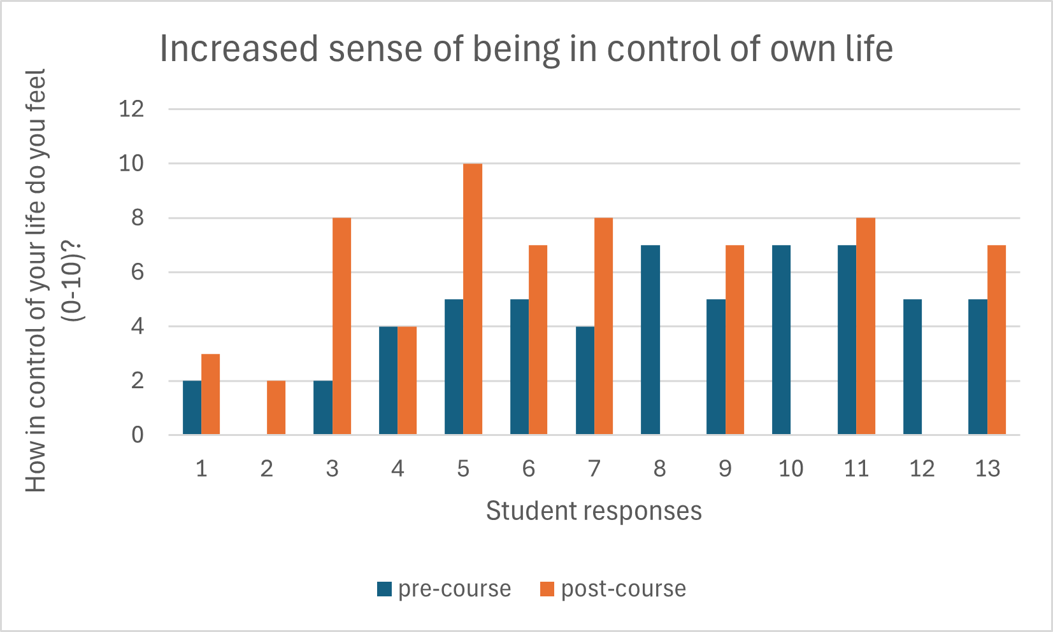
Figure 6: increase sense of control (student 2 scored 0 pre-course)
Students’ ability to see and take opportunities had the greatest average increase, rising from 4.4 to 7.4 out of 10, an increase of 68% (figure 7).

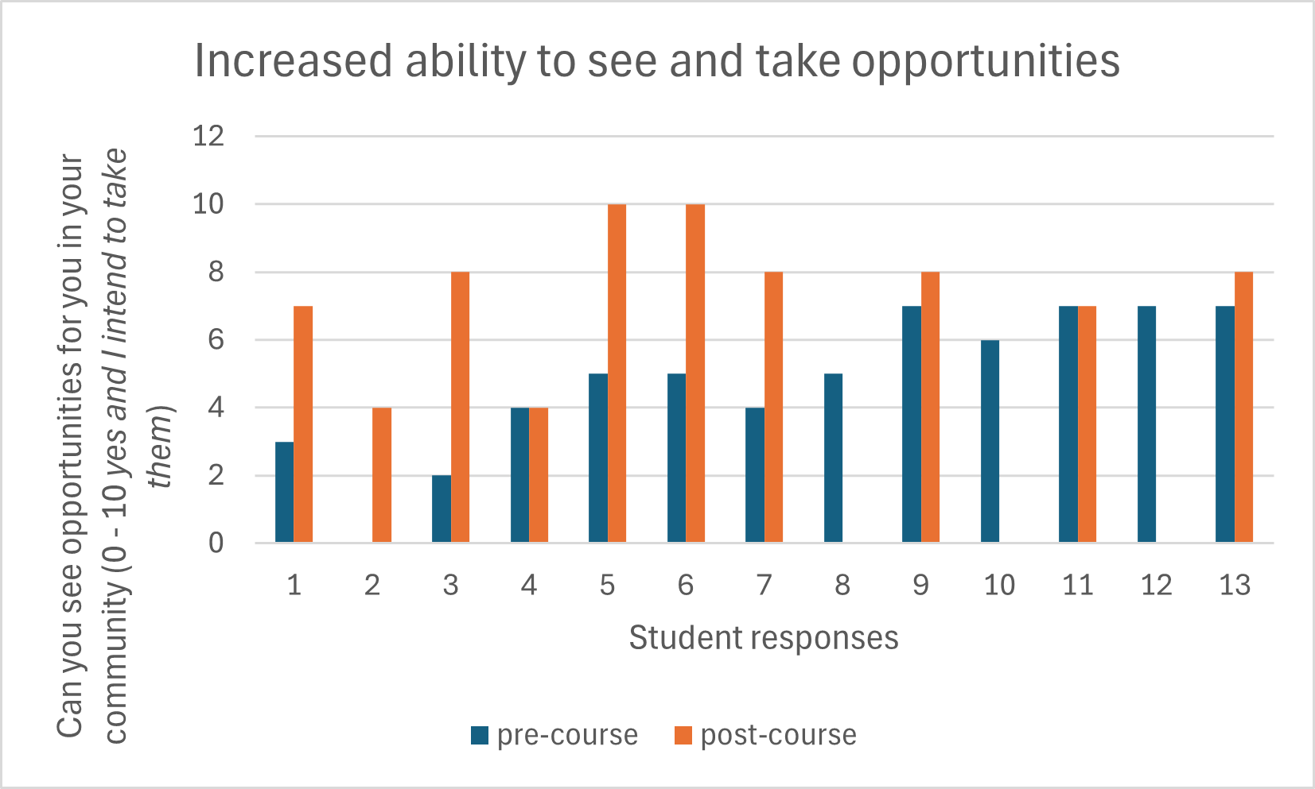
Figure 7 increased sense of opportunity (student 2 scored 0 pre-course)
7 out of 10 students planned to take up further art-based creative opportunities. These varied from specific activities such as “jewellery making” to feeling able to “Try new things”. One student reported, "Hoping to return to work one day a week and share myself creatively.”
At the end of the course, students were asked to reflect on the top three things they hope to get out of attending the course (as listed in figure 2). The resulting word cloud (figure 8) shows that museum objects and creativity are important tools that can be combined to meet strategic health priorities.
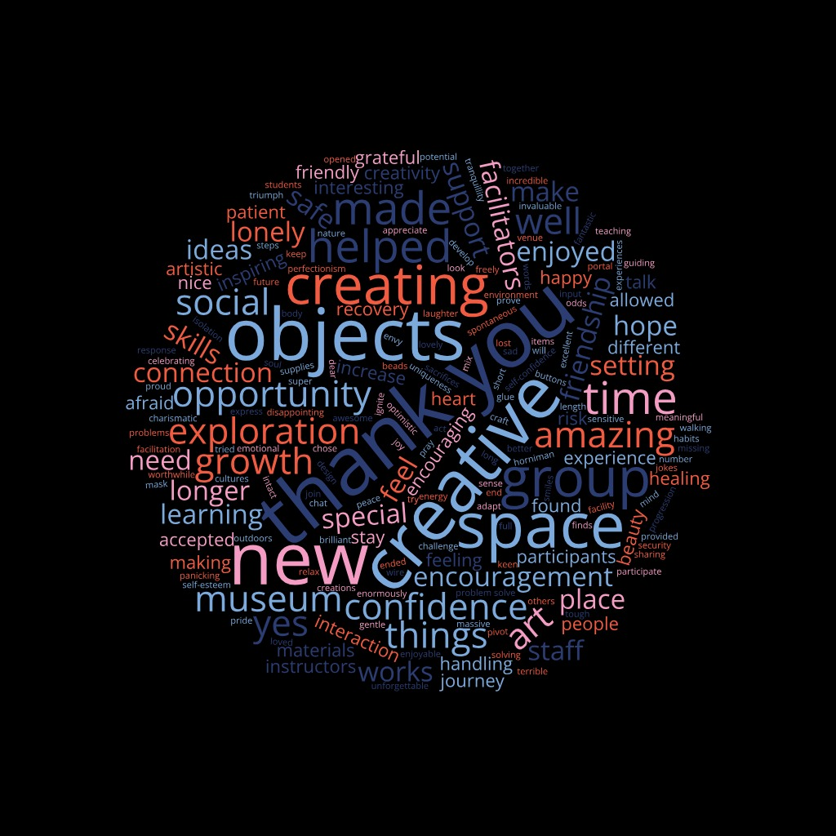
Figure 8: student reflections on strategic health outcomes
Lessons Learned
All course facilitators met 2 weeks after the end of the course to respond to student feedback and reflect together on the course. We agreed the course would benefit from including more recovery methodology and more opportunities for Peer Trainers to share their experiences as well as a clearly defining the course as psychoeducation rather than psychotherapy. In response, future courses would: focus more on recovery education themes, aims and objectives from the outset; keeping reflection on artwork in present or future tense rather than exploring past pain; scaffold student reflection by ensuring Peer Trainers share in early sessions. Students asked for more time. Although a longer course would be logistically challenging, session time could increase from 1.5 to 2 hours.

The legacy
Funding has been secured from Museums Association and Julia Rausing Trust to repeat this course twice over the next 2 years. 3 students specifically asked for the course to be repeated. One wrote, “From the bottom of my heart I want to say thank you… You created a safe, welcoming space each week- A place where we could simply be ourselves, where we could meet new people and form friendships… The course has truly inspired me to explore new forms of art, to think and act in ways that truly support my healing. I already envy the new participants because I know they are about to experience something special- time well spent, full of connection and growth.”

Appendix 1: Evaluation form
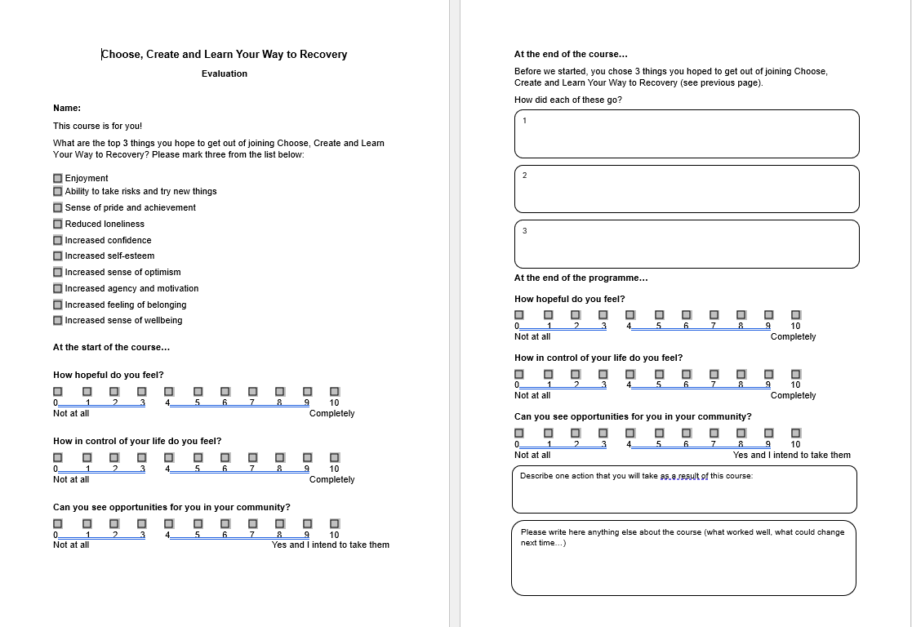

Allard, J. et al. (2024) Evaluating the impact of a UK recovery college on mental well-being: pre- and post-intervention study BJPsych Open 10, 87, pp. 1–9. doi: 10.1192/bjo.2023.646. Available at: S2056472423006464jra 1..9
The Health Outcomes & Impacts Guide, part of the Creative Health Impact Framework
Home
Developing our shared approach to Neighbourhood development, Board Papers January 2025

