Creative Health Case Study: Horniman @ Ladywell Creative Wellbeing Pop-up
Summary information
Title: Horniman @ Ladywell Creative Wellbeing Pop-up
Author: Julia Cort, Art Psychotherapist, Horniman Museum and Gardens; Siobhan Lennon, Specialist Art Psychotherapist, South London and Maudsley NHS Foundation Trust
Date: September 2025
Partners: Horniman Museum and Gardens (the Horniman); South London and Maudsley NHS Foundation Trust (SLaM)
Funders: Department for Culture, Media and Sport (DCMS)

Introduction
This collaboration between The Horniman Museum & Gardens and The Ladywell Unit (a SLaM NHS acute inpatient mental health unit in Lewisham Hospital), offered combined artmaking and museum object handling (figure 1). The project ran over 4 sessions every Wednesday afternoon in August 2025 at Ladywell Unit, reaching 72 people. It engaged patients experiencing the often distressing admission to acute inpatient wards with an informal, enjoyable, creative and therapeutic opportunity. The project also engaged with staff and family members, promoting positive connection, joint attention and cultural curiosity. The project was facilitated by Art Psychotherapists from both organisations, allowing careful consideration of factors influencing the above aims and ensuring the physical and emotional safety of all participants. All measured wellbeing outcomes were achieved, with enjoyment, increased motivation and feeling more hopeful scoring highest. One patient commented, “Great activities and lovely people!”
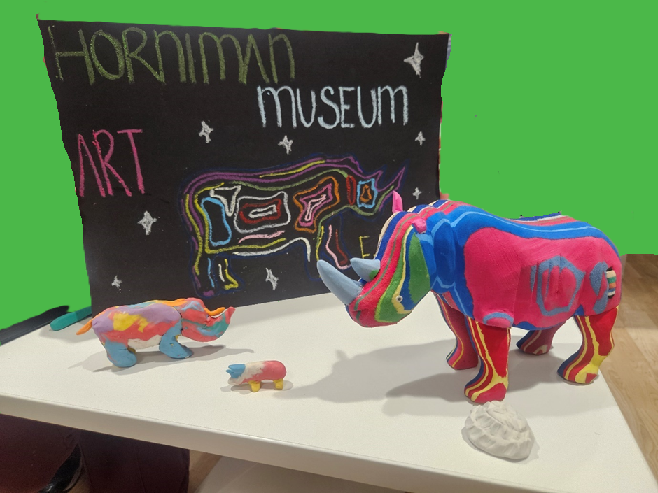
Figure 1: Horniman handling object with creative responses from inpatients and staff. Artwork materials: Plasticine, paper, pastel.

The Need
Being admitted to acute inpatient mental health wards, can be traumatic and impose severe restrictions on everyday life. Bringing the Horniman collection (a local resource) to meet the patients, carers and staff in the unit sought to soften restrictive experiences by offering an opportunity to engage with the outside world whilst managing risk safely.
National Institute for Health and Care Excellence recommends arts therapies for adults experiencing psychotic symptoms, yet only 1 of 6 Ladywell wards offers arts therapies.
Previous Horniman object-based inpatient interventions have been well-received , . A collaboration between in-house Art Psychotherapists at Horniman and Ladywell had potential to support more patients.

The Approach
A pilot object handling session (without art materials) for patients and staff was conducted on the ward where Ladywell’s Art Psychotherapist is employed. Both Art Psychotherapists reflected together on observations and informal feedback to create a programme that maximised:
- access for all eligible people staying in, working at or visiting Ladywell Unit
- use of museum objects and art materials for wellbeing
- patient safety
- support of patient treatment plans
On 4 Wednesdays in August 2025, 1.30-3pm, Art Psychotherapists from Ladywell and Horniman facilitated a pop-up creative wellbeing intervention in the Reception Foyer of the Ladywell Unit (figure 2). Each week, people at Ladywell were encouraged to engage with 20 museum objects from the Horniman handling collection in a multisensory way (figure 3). Participants looked at, touched, smelt, wore, played and listened to the objects. This allowed personal experiences of the artifacts and their cultural meanings. Object selection was honed week-on-week to meet participant need.
Participants were invited to respond creatively using art materials of their choosing, including papers, pens, pastels, pencils, charcoal and Plasticine, limited scissors and pencil sharpeners. Some participants created artwork, sometimes responding directly to the objects (figure 1) and sometimes not (figure 4).

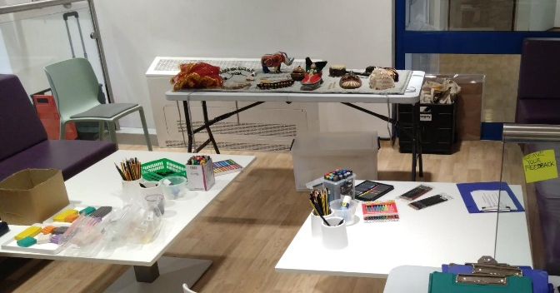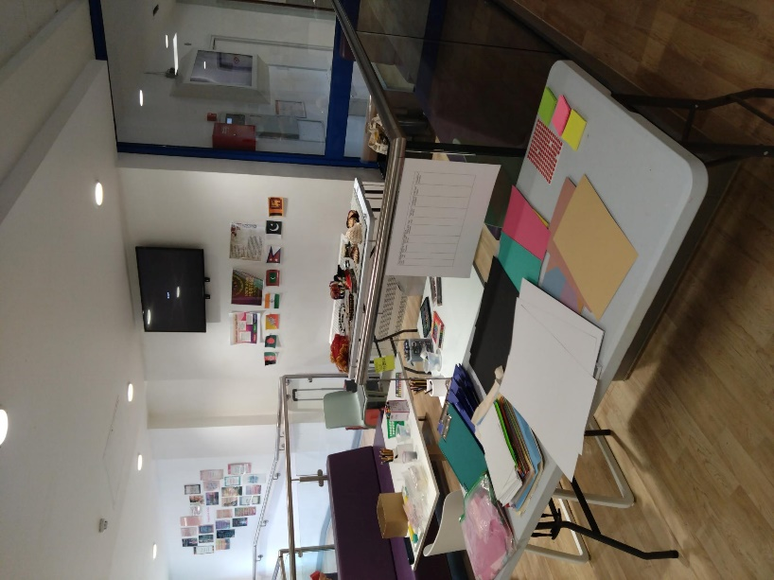
Figure 2: session set-up: museum objects and art materials in Ladywell Unit foyer.

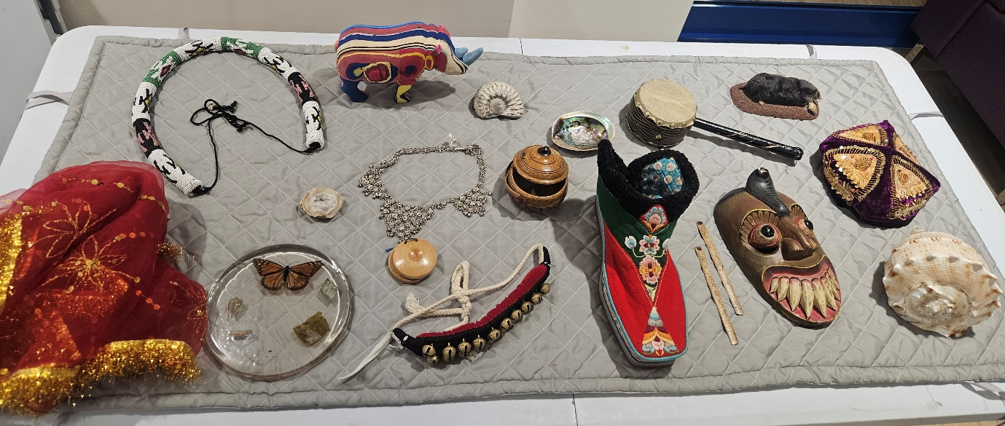
Figure 3: week 1 museum object selection.
There were 72 instances of participation across 4 sessions with participation ranging from 11 to 28. Most participants were patients, with some participation from staff members and 1 family member visiting a patient.
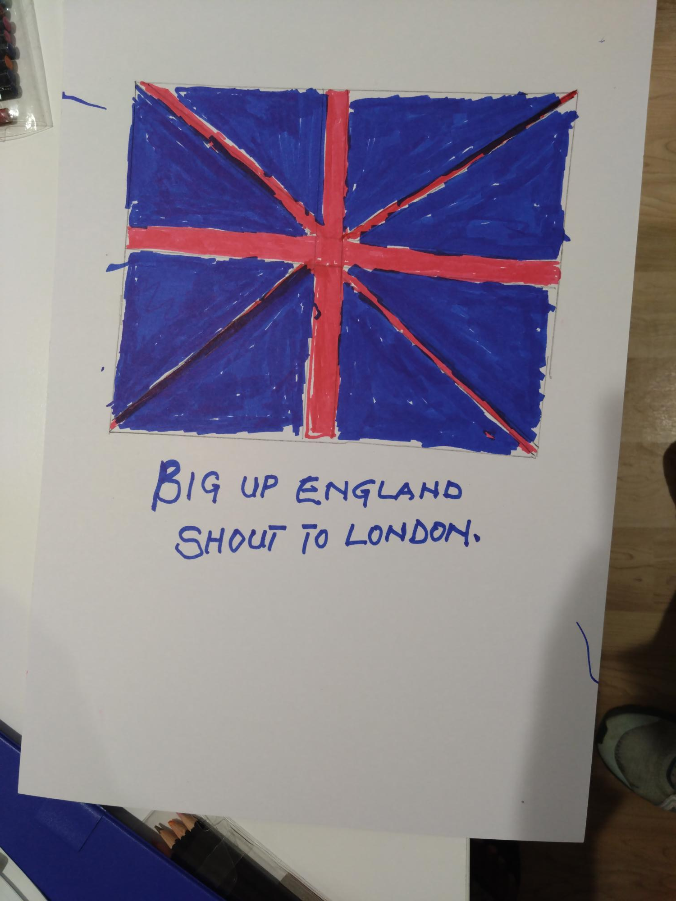
Figure 4: Example of patient engagement with art materials: paper, felt-tip pen. Approx: 58x29cm
The impact
As light touch evaluation, participants were asked to stick a dot in any column related to a benefit they got from the session as they left the activity. Options were taken from the strategic health priorities of South East London Integrated Care Board (SEL ICB). These options were: enjoyment; feeling safe; feeling supported; trying new things; ability to engage and concentrate; sense of pride and achievement; increased confidence; increased self-esteem; increased sense of hope; increased agency and motivation. Participants were also invited to leave a comment if they wished. Our intervention scored highly on all of the SEL ICB indicators measured (figure 5).
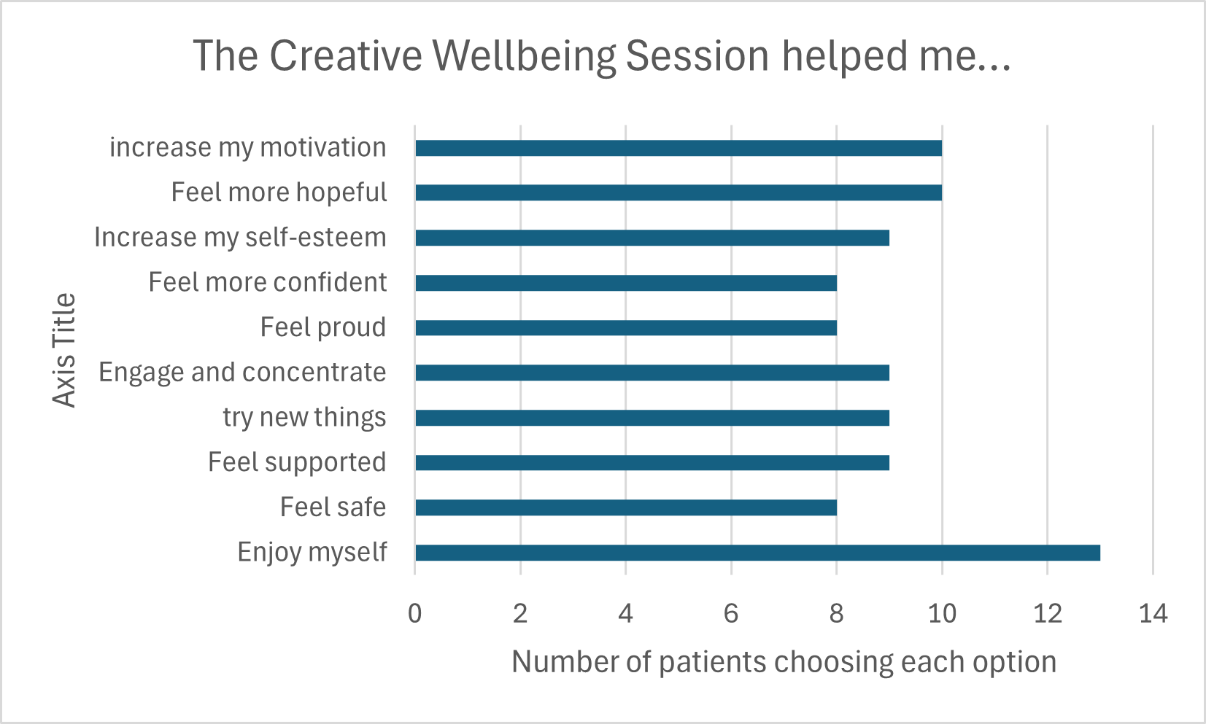
Figure 5: table of patients’ reported benefits after taking part in the session.
These scores were in line with Art Psychotherapists’ reflections on the sessions. Higher reported levels of enjoyment and motivation could have been due to free connection between art materials and objects. Increased sense of hope could be caused by bringing a local cultural resource into the unit, offering this experience to patients who may not currently be able to connect with such a resource due to being restricted in their freedoms.
In a setting where risks to patient physical and mental safety are generally higher than in community settings, this intervention reported no incidents. Patients from different wards mixed together (often for the first time) and no altercations occurred. Overstimulation was avoided as the option to go into the garden during the same timeslot provided a breakout space.
Lessons Learned
Ward staff support was vital to the project’s success. Participation rates were lower when fewer staff were available to escort patients off wards.
Future iterations would prioritise staff awareness and understanding. This might include weekly staff reminders, using this report to exemplify patient benefits, or experiential taster sessions for staff.
On average, patients from the older adult ward engaged with objects for longer than patients from other wards.

Offering patients vouchers to visit Horniman exhibitions for free at a time of their choosing was helpful. The no-strings invitation conveyed respect, suggested a post-inpatient, and provided something patients could offer visiting friends and family.
Both therapists felt this short project offered a valuable taste of collaborative working.

The legacy
Some patients left their wards for the first time since admission to attend the sessions. Future iterations could focus on providing a safe first step out of the ward and explicitly inviting people who felt they wanted to leave the ward. Sessions could be themed (e.g. your journey after Ladywell).
The Horniman has received funding to continue Art Psychotherapy programmes for two years. This opportunity means inpatient offers will need to be more aligned with Art Psychotherapy than with therapeutic artmaking. It offers exciting potential to link offers on inpatient wards with socially prescribed Art Psychotherapy based at the Horniman, and for work with older adult mental health inpatients.

Contact details:
Julia Cort: jcort@horniman.ac.uk
Siobhan Lennon: siobhan.lennon@slam.nhs.uk

Psychological therapy | Information for the public | Psychosis and schizophrenia in adults: prevention and management | Guidance | NICE
Cort, J. (2019) ‘Mini museums in a box: co-producing open access handling boxes’, in B. De Nil (ed) Cultural heritage for wellbeing. Brussels: FARO, pp. 56-64.
JOAP.case_.study_.pdf
The Health Outcomes & Impacts Guide, part of the Creative Health Impact Framework

