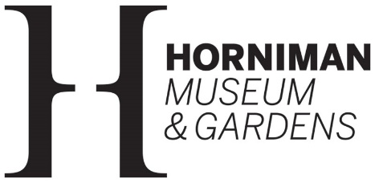

Play area evaluation Volunteer
Role description

The Horniman Museum and Gardens is a unique attraction in southeast London where global cultures and the natural world are brought together for everyone to enjoy. The Museum holds internationally important collections of anthropology and musical instruments, as well as a popular natural history gallery and Aquarium. The 16 acres of beautiful Gardens feature a tropical Butterfly House and offer stunning views across London.

Main purpose
In late spring 2026 we are opening a new Café and Play Area in the Horniman’s grounds, as well as improving access to the historical Nature Trail. We need to better understand how visitors to the Gardens use these new spaces. The role, which will be overseen by the Audience Insight and Marketing Manager, will focus on observational research in the Gardens over the opening months of the new spaces.

Tasks include:
- Clicker counting visitors to the play area over a set period of time
- Observing and documenting how visitors are using the play area and Nature Trail access
- Sharing findings, insights and potential recommendations with the Audience Insight and Marketing Manager

Level of commitment and any conditions
This is a fixed term role, 1st June to 30th June. There will be 8 2 hour sessions, on one mid-week date and one weekend date each week. We can also be flexible on the days of the week. Due to the level or supervision available, this role is only open to those aged 18 and over

This role would suit someone who:
- Is able to volunteer independently with minimum supervision
- Enjoys being outdoors
- Has good observational skills and is confident with data capture and reporting
- Good attention to detail
- Is able to adhere to health and safety and safeguarding instructions

The museum offers volunteers:
- Opportunities for personal development in a supportive learning environment
- Reimbursement of travel expenses
- Special events for volunteers such as behind-the-scenes talks and socials
- A 20% discount at the shop and 40% in the café
- Free entry to paid areas of the museum
- Free reciprocal entry to National Museum Directors’ Council members’ sites, after 4 months volunteering

We are committed to diversity and inclusion and welcome applications from people of all backgrounds and circumstances. Adjustments are available to support your application and placement in this role. Please get in touch if you have any questions.

To apply
Please complete the online application form or ask for an application form by emailing: volunteering@horniman.ac.uk

Closing date for applications: 7 May

We will hold informal interviews on 14 May with an anticipated start date of w/c 1 June

