Welcome to the Horniman Museum and Gardens.

We hope you enjoy your visit to the Voyage to the Deep exhibition.


Here’s a little bit of information about what to expect.
Highlights noisy areas
Highlights a change in light levels

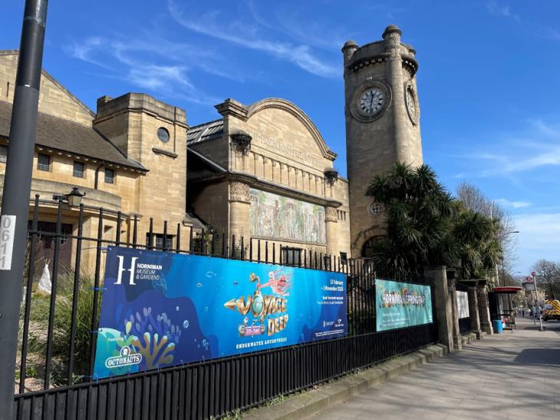
- This is what the Horniman looks like.
- You can see the Clocktower as you approach the Museum.


- The Gardens are open from 7:15am until 8.30pm.
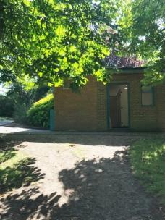
- The Horniman Café next to the main Museum is open from 9am until 5pm.
- The toilet block in the Gardens, that is closest to the main Museum, is open from 7.15am – 8.30pm.
- There are more toilets available in the Museum during opening hours.

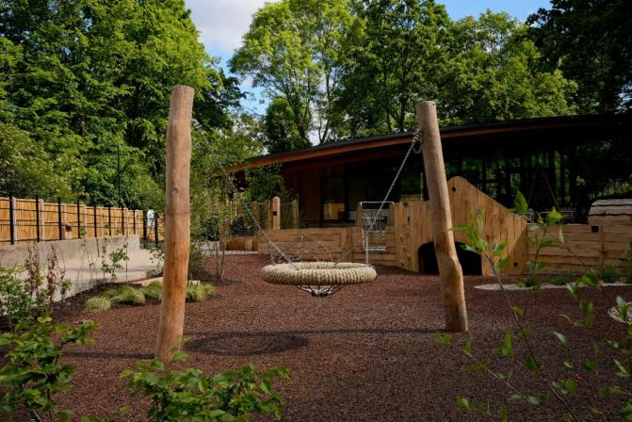
- There are additional toilets down at our new Gardens Café and Kusama Nature Play Area.
- The toilets are directly behind the Café. They are open from 7.15am – 8.30pm.
- The new Gardens Café is open from 8am – 6pm.
- The Café and Kusama Nature Play Area are located at the bottom of the Meadow Field.

https://www.horniman.ac.uk/wp-content/uploads/2020/02/gardens-map-2018.pdf
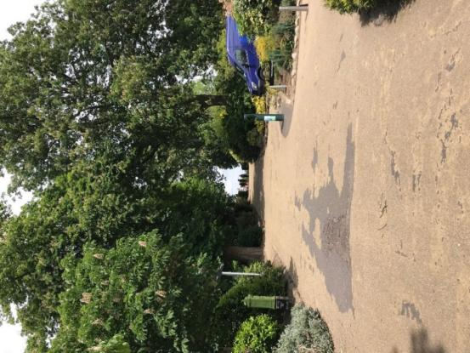
- To get into the Museum you can walk up the avenue from the London Road gates.
- You then turn right and walk up the ramp to the Museum entrance.
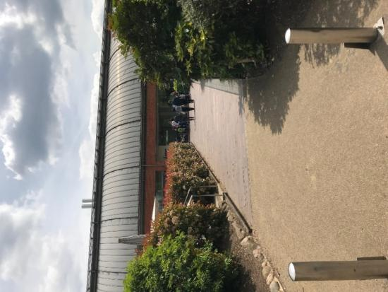
- You might see a van like this one making a delivery to the Museum.
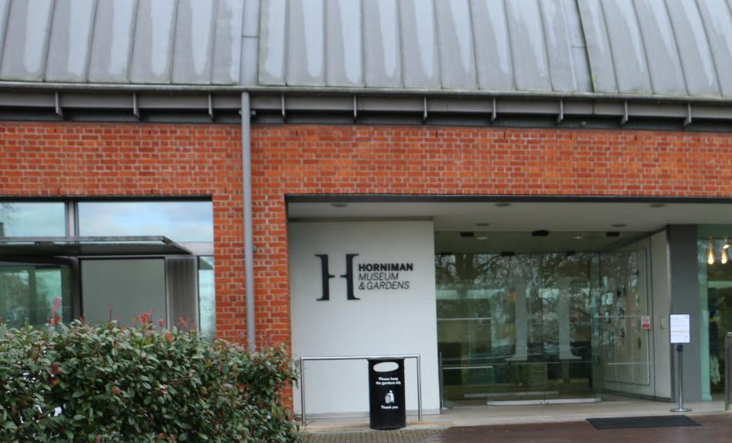
- This is the entrance to the Museum. You go through two automatic glass doors.
- The Museum is open daily from 10am to 5.30pm.
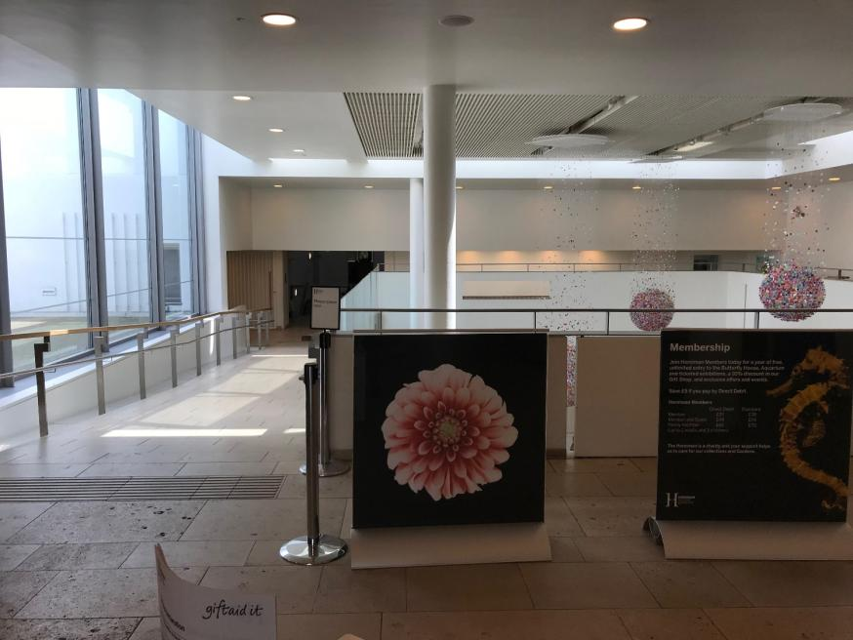
- This is what you will see in the main entrance. This area can be a little noisy.

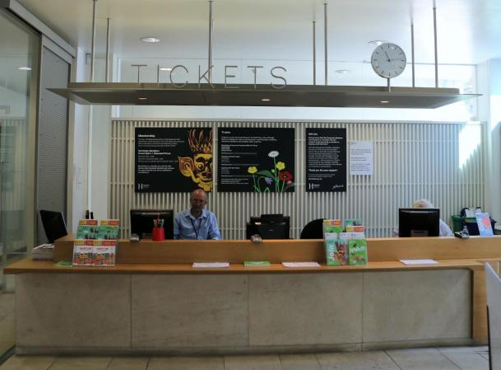
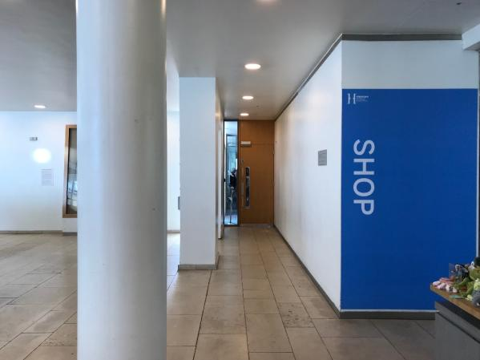
- Just inside on the left you’ll see the ticket desk. Our friendly staff, like Tony, are waiting to help you enjoy your visit.
- To the right of the shop is a door to the Education Centre. This is the entrance to the Chill Out space.

- The Chill Out space will be open from 5pm until 7pm.
- You can relax in here, play with some toys or maybe eat or drink something you have brought with you.
- There is another Chill Out space in the room behind the first one, just in case anyone needs some more space or is upset and wants a quieter space to relax in.
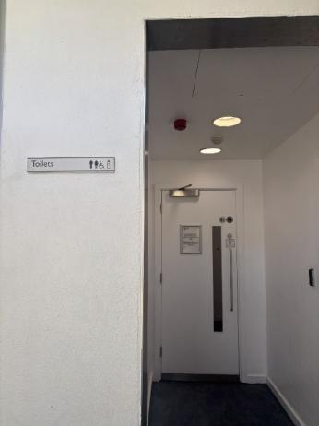
- There are also toilets nearby, just off the little hallway leading back into the main Museum.
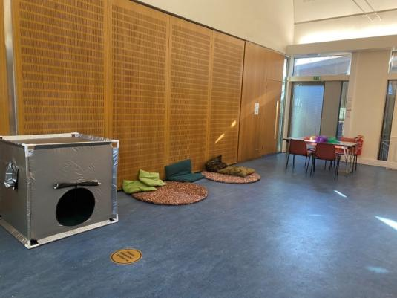
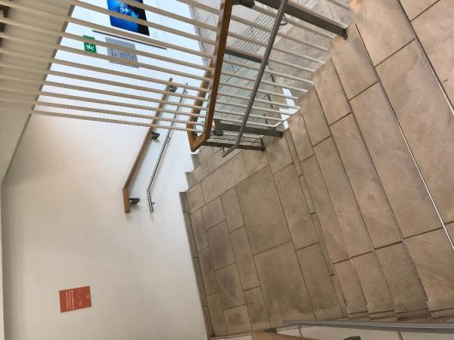
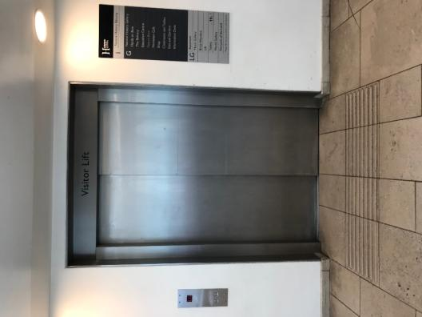
To get to Voyage to the Deep you could take the stairs, or the lift – whichever you prefer.

- If you arrive downstairs via the lift, Voyage to the Deep will be immediately to your right as you come out of the lift.
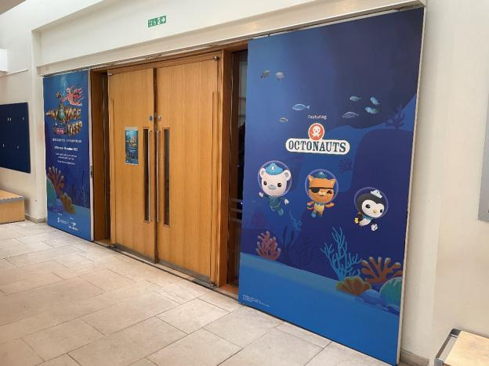
- If you come down the stairs then Voyage to the Deep will also be to your right.

- The area in between the two exhibitions is called Gallery Square.
- There are some toilets off Gallery Square.
- If you are visiting out of the Museum’s usual opening hours you may see some cleaners working during your visit. There might be noise from vacuum cleaners etc.

Inside Voyage to the Deep the house lights will be up, so it won’t be much darker than Gallery Square.

- There are some areas of this exhibition that make noise.
- The noisiest interactive is the pipe organ which makes very loud noises when the keys are pressed.
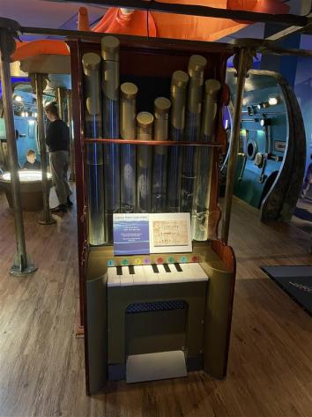
- This interactive is very noisy!
- There is some background noise from the inflatable on top of the submarine. If this noise bothers you please let us know so we can switch it off.
- There is a flashing light by one of the entrances to the submarine.
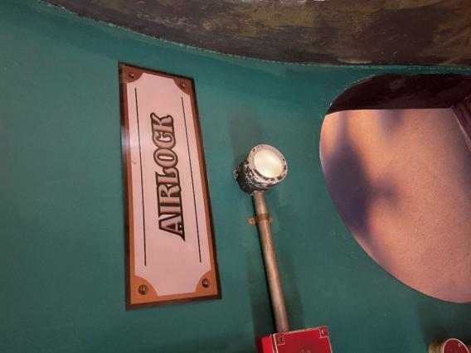
- When you are finished having a look around Voyage to the Deep you can explore the rest of Museum and the Aquarium.

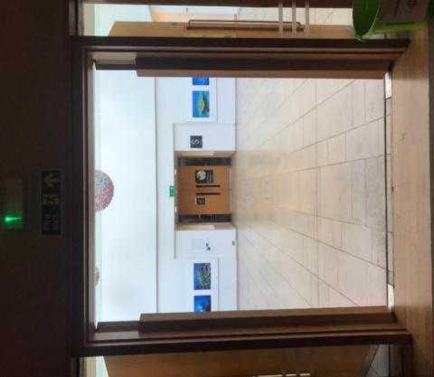
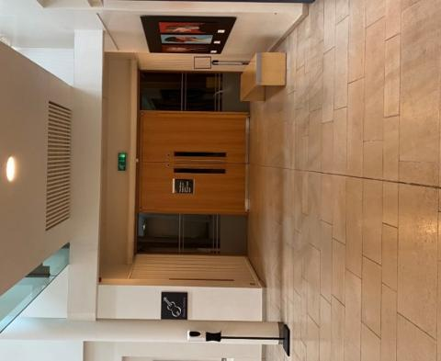
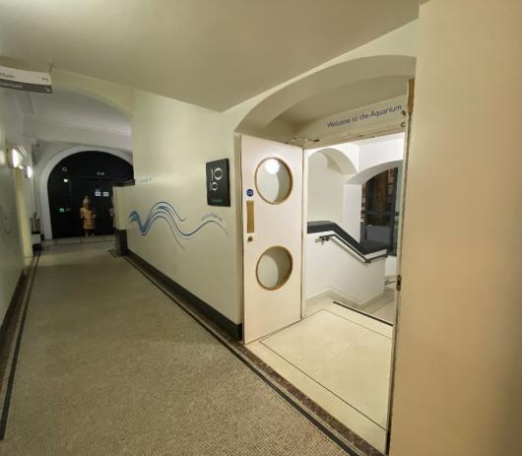
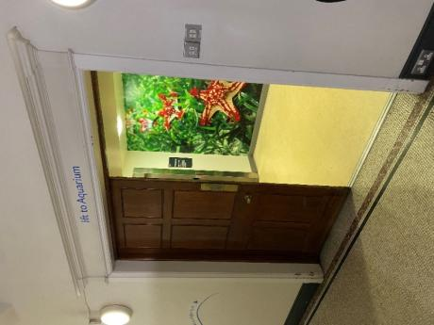
- Remember when you come out into Gallery Square it may seem a little bright.
If you turn left when you come out of Voyage to the Deep and walk through Gallery Square you can go down to our Aquarium. You can either go down the stairs or take the lift.

- Our Aquarium might be small but you can see fish and other water creatures from different parts of the world.
- Staff might still be doing work in the Aquarium when you arrive, so there may be changes in noise and light level throughout your visit.
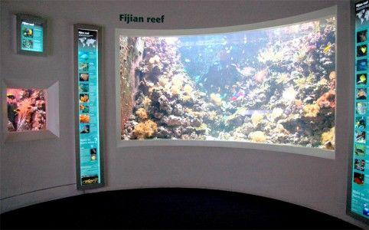
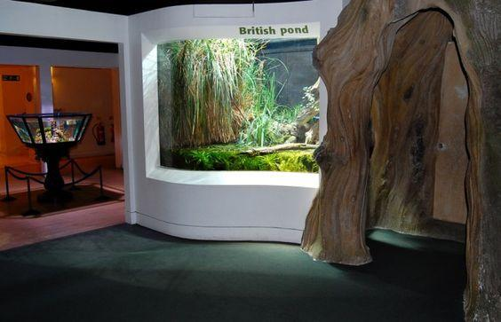
- Although the lights are turned down a bit in the Aquarium, all of the tanks have their own lighting so it is still quite bright.

If you want to watch more videos that show you how to get to the Museum or walk to different parts of the Museum and Gardens then we have more films on our YouTube playlist ‘Watching the Route’.
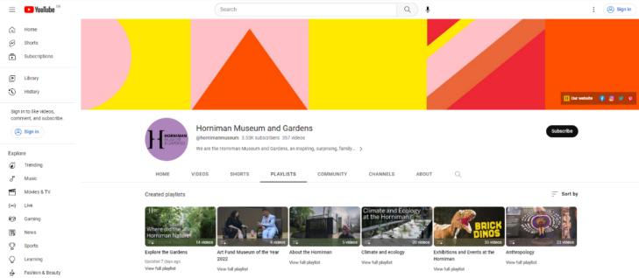
https://www.youtube.com/playlist?list=PLVLBYq1ay8T61ySxW8RZGoW56W718GDUW We hope you enjoy your visit.

